mHealth Alliance

*me*Health Framework for MNCH

A person-centric, *m*Health + *e*Health Framework for  
Maternal, Newborn and Child Health  
Draft 0.9  
November 2011



Prepared by: ecGroup Inc.

www.ecgroupinc.com

Contents

Executive Summary 1

Overview and Context 1

The current realities… 1

Strategies and tactics… 2

Elements of a *me*Health Framework 3

Documenting the Framework… 4

The Collaborative Health Platform 7

Overview and Context 9

The Scope of the Problem 9

Realities… and implications 10

Reality #1 – ICT is a key component 10

Reality #2 – mHealth is the way to achieve REACH and SCALE in the developing world 11

Reality #3 – The status quo will not lead to success 12

Reality #4 – The “medical model” of care is not a viable option for developing countries 12

The Importance of a Systems Approach 13

Strategy: Universally Accessible, Person-centric, Primary Care 13

Strategy: Task-Shifting 13

Strategy: Evidence-based Guidelines 14

Strategy: Health System Management 14

The Role of *me*Health 14

Defining *me*Health 15

Tactic: Employ ICT to Improve Efficiency and Effectiveness 15

Tactic: “Systematize” Standard Care Processes 16

Tactic: Deploy Shared Infrastructure for Healthcare 16

Tactic: Generate Reportable Metrics From ICT-supported Care Activities 17

Tactic: Seek Innovative Ways to Fund Universal Healthcare 17

Describing the Framework 19

An Enterprise Architecture for *me*Health 19

What is Enterprise Architecture? 19

Describing the *me*Health EA Viewpoints 20

A Functional Profile for MNCH 21

Family Planning 22

Safe Abortion Care 22

Pregnancy Care 22

Childbirth Care 23

Postpartum Care 23

Newborn Care 23

Infancy and Childhood Care 23

Reportable Metrics 24

Unpacking the MNCH Functional Profile 25

Actors 25

Settings 25

Activities 26

Describing the Viewpoints 26

Use Case Story Characters 26

Use Case Story Settings 27

Workflow Diagrams 27

Sequence Diagrams 28

Information Models 29

Use Case Stories 32

Grace Enrolls Mosa to Receive *me*Health Information 32

The Characters 32

The Story 32

meHealth Implications 32

Workflow Diagram 33

Sequence Diagram – Enrollment 35

Sequence Diagram – Information Dissemination 37

Mosa Receives Care 39

The Characters 39

Act 1 – Grace and Mosa Have a Routine Care Visit 39

Act 2 – Mosa and Joshua have a Referred Care Visit 40

Workflow Diagram (Acts 1 & 2) 42

Sequence Diagram – Act 1 44

Sequence Diagram – Act 2 47

Samuel Conducts Lab Tests and Records Results 49

The Characters 49

The Story 49

Sequence Diagram 52

Grace Provides Mosa with Medications 54

The Characters 54

The Story 54

Workflow 54

Sequence Diagram 55

Administrative Use Cases 57

The Characters 57

Sarah Enrolls Grace as a CHW 57

Sarah Reviews CHW Performance 57

Joshua Records Vital Statistics 57

Information Model 59

Overview 59

Subject of Care 59

Provider of Care 60

Facility/Location 61

Care Guideline/Plan 61

Care Coordination Document 61

Operationalizing the Framework 63

The Collaborative Health Platform 63

Technical Artefacts 64

Continuous Improvement and Evolution 64

References 65

# Executive Summary

## Overview and Context

The approach employed in developing the meHealth Framework may be characterized as follows:

* There are realities that characterize the problem being addressed
* Strategies for addressing the problem must respect the realities
* Tactics must support the strategies
* It is the role of the meHealth Framework to give effect to the tactics; to operationalize them

### The current realities…

The WHO has identified that the implementation of ICT (information and communication technologies) is a key to its strategies to address maternal, newborn and child health. It encourages member states to embrace these technologies and has recently called for accelerated investments to help achieve millennium development goals (MDGs) 4 & 5.

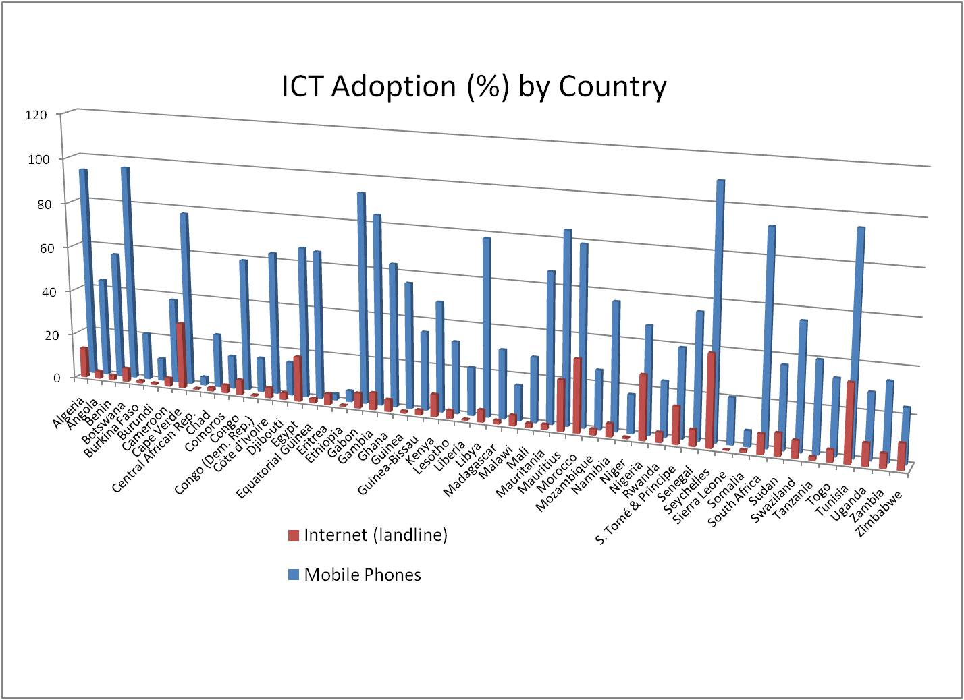

Source: ICT statistics for Africa (ITU, 2009)

In developing countries, embracing ICT means embracing mobile phone technology (mHealth) as the edge device for eHealth. Mobile phone adoption in lower and middle income countries (LMIC) far outpaces “land line” infrastructure, and it continues to grow at a +40% compound annual growth rate. If we are going to achieve reach and scale, mHealth is way to do it.

Based on the 2011 MDG report card, we will meet only 6 of 27 “targets”… and in 2 cases the metrics indicate the situation has actually become worse, not better.

If we keep on the path we have been following, however, we will not achieve the healthcare MDGs. Many believe that a course correction is needed to the very strategy of healthcare investment in LMICs. The focus on disease specific or segment targeted programs (even including on maternal health) must give way to a broader approach; the person-centred healthcare approach based on strengthened primary care espoused over 30 years ago in the Alma Ata Declaration.

A re-embracing of the Alma Ata tenets underlies another stark reality: the “medical model” of the developed world is simply not appropriate in developing countries. A community care model is key; task shifting can and should be adopted in order to provide broad support for interventions and to help alleviate the shortages of clinical personnel in many areas. These interventions should adhere to evidence-based guidelines and ICT can play a crucial role in supporting consistent, quality care delivery at the community level.

### Strategies and tactics…

The strategies and tactics that respect these realities may be characterized as follows:

#### Embrace Alma Ata

* Support a health system focused on a generalized, coherent, continuity of care rooted in a strong portfolio of services offered at the primary care level.
* Adopt a holistic, person-centred (rather than disease-centred) healthcare approach.
* Work towards universal access to a defined portfolio of healthcare services funded through a pre-paid (insurance) model.

#### Operationalize evidence based, community-delivered care

* Focus on education and preventative care.
* Employ task shifting to forgive the shortages of trained clinicians.
* Use ICT, especially mHealth, to train, educate, and support community health workers in evidence-based workflows.

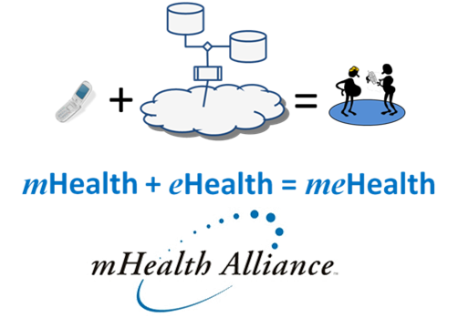

#### Adopt a diagonal approach to health system strengthening

* Use shared ICT infrastructure to embrace and extend existing care silos. Support continuity of care by connecting the existing, disparate dots into a cohesive healthcare picture for each subject of care.
* Leverage *me*Health; a person-centric combination of mHealth + eHealth that makes use of “light” mobile phones at the edge of the network to invoke and manage the execution of “heavy” work in the middle of the network.

## Elements of a *me*Health Framework

The meHealth Framework for MNCH describes an enterprise architecture for person-centric, mHealth and eHealth infrastructure specifically supporting maternal, newborn and child health workflows. The ICT requirements for the architecture are distilled from the seminal WHO document *Every Woman Every Child (EWEC)*.

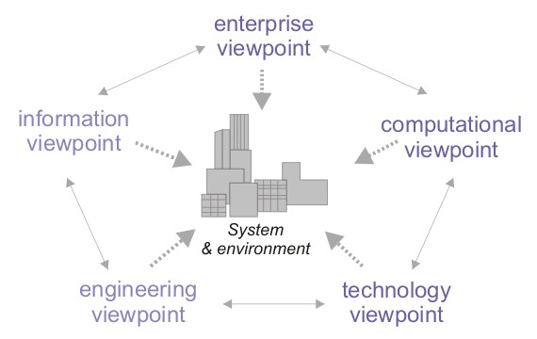

Source: Wikipedia (<http://en.wikipedia.org/wiki/RM-ODP>)

The meHealth Framework employed a standards-based way of expressing its enterprise architecture based on ISO-10746.

The Framework is described using a set of viewpoints. The Enterprise Viewpoint (EV) for the *me*Health Framework describes the care delivery workflows and functions that characterize the healthcare system. The EV is expressed through a set of characteristic use case stories, which personify specific care delivery use cases, and associated workflow diagrams which follow the Business Process Model and Notation (BPMN) standard.

The Information Viewpoint (IV) is related to the EV; the IV answers the question: what information is needed to drive the use cases documented by the EV? This information is broken down into data objects, or classes, and expressed using the Unified Markup Language (UML) standard for Class Diagrams. Wherever possible, standards-based data specifications have been leveraged and referenced.

The Computational Viewpoint (CV) answers the question: which participants in the workflow must exchange the information documented in the IV, and how is that “conversation” conducted? The CV is documented using the UML standard for Sequence Diagrams. As the name implies, Sequence Diagrams describe the sequence of information exchanges between workflow participants.

It was treated as “out of scope” to articulate the Engineering and Technology viewpoints of the meHealth Framework.

### Documenting the Framework…

The requirements distilled from *Every Woman, Every Child* (EWEC) are expressed as use case stories. These stories involve actors, settings and activities – and all of these are “personified” into a group of named characters participating in archetypal care workflows. The characters in the Use Case Stories described in this document are listed below.

* Mosa is a young pregnant woman with 2 small children. She lives in a rural village in sub Saharan Africa. She has access to a mobile phone which is shared among members of her extended family. Mosa is not illiterate.
* Benjamin is Mosa’s husband. Benjamin is literate.
* Grace is a community health worker (CHW) who works in Mosa’s village.
* Sarah is Grace’s CHW Manager
* Joshua is the nurse at the local Health Centre
* Marion is the physician at the Referral Centre (HOSPITAL)
* Samuel is a lab technician at a regional lab (LAB)

The scenarios that are documented are:

* Mosa enrolls in a *me*Health information service
* Mosa receives care
* Samuel conducts lab tests and reports results
* Grace provides Mosa with medications
* Administrative scenarios:
  + Sarah enrolls Grace as a CHW
  + Sarah reviews CHW performance
  + Joshua records vital statistics

Use case stories are a very effective means of describing the enterprise viewpoint of an architecture.

In a typical use case story example, a young woman (Mosa) who lives in a rural village is visited by the community health worker (Grace). Grace uses her mobile phone to authenticate Mosa, to work through a guideline-based antenatal care visit, and to direct Mosa’s care based on the recorded observations and measurements.

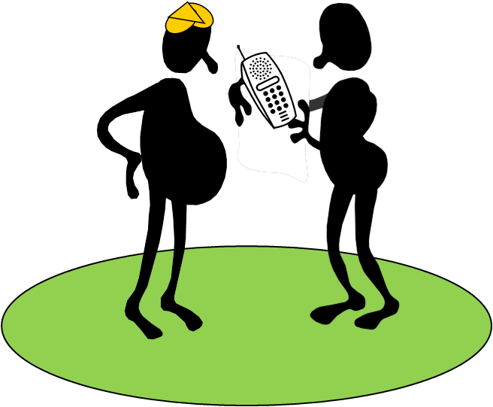

This simple use case story may be expressed as an interaction of technical elements. Analysis of the entire body of stories revealed common, archetypal patterns which could be illustrated by workflow diagrams. An example diagram depicting the story of Mosa and Grace’s antenatal care visit is shown below. The colour coding of the swim lane diagrams follows the convention in EWEC. The “green lane” indicates routine processes; the “yellow lane” is for escalated processes that do not require referral and the “red lane” indicates escalation to a referral location.



Workflow Diagram: Care Delivery

The expression of the workflow in a Sequence Diagram more precisely articulates the participants and illustrates their interactions with each other in satisfaction of the care delivery process. Sequence Diagrams follow a standard format defined by the Unified Modeling Language (UML). The UML diagram for Mosa and Grace’s antenatal care visit is shown in the graphic below.

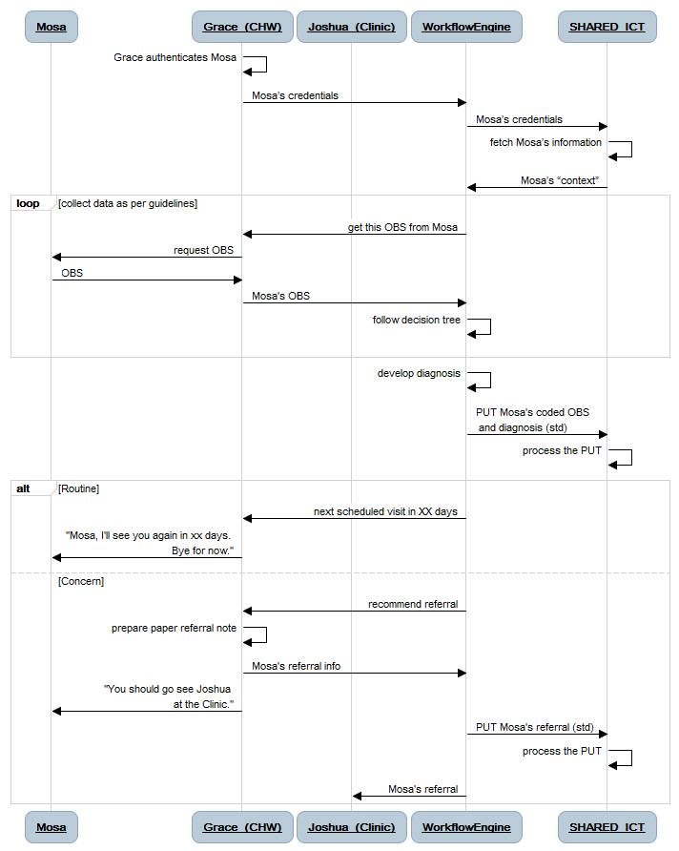

Sequence Diagram – Care Delivery

The information that must be exchanged by the participating parties, and the ways that this information is related to other information, may be expressed using an Information Model. For the *me*Health Framework, standards-based information models were selected that generically describe the shared content. An example, informed by the ISO standard for Health Information System Architecture (HISA, ISO 12967-2) is shown below. Each of the elements in the information model is described in further detail.



Information Model informed by ISO 12967-2

The expression of the *m*eHealth Framework using standardized diagramming tools helps the Framework be more “consumable” by enterprise architects, business analysts, and software system developers. The choice to express only the Enterprise, Information and Computational viewpoints of the Framework means that it is not prescriptive regarding the specific IT design (Engineering Viewpoint) or the technology stacks (Technology Viewpoint) that may be used to realize a working version of the Framework.

An example of engineering and technology based on the Framework has been developed by a companion project led by NetHope and funded by USAID/PEPFAR. Information regarding this example is available at the mHealth Alliance’s HUB collaboration site. The link to this companion work is:

<http://www.healthunbound.org/group/collaborative-health-platform>

## The Collaborative Health Platform

The meHealth Framework for MNCH has been developed as part of the “the commons”; a shared asset that may be employed by any stakeholder in the m/eHealth community and leveraged or extended as they see fit. The premise that a commons would be developed and curated was explored in May 2011 by a group of donors, implementers and thought leaders that met at the Greentree Centre in New York City. The development of a Collaborative Health Platform was discussed at this meeting. A diagram illustrating the concept of how a collaborative “virtuous circle” could be realized is shown below.

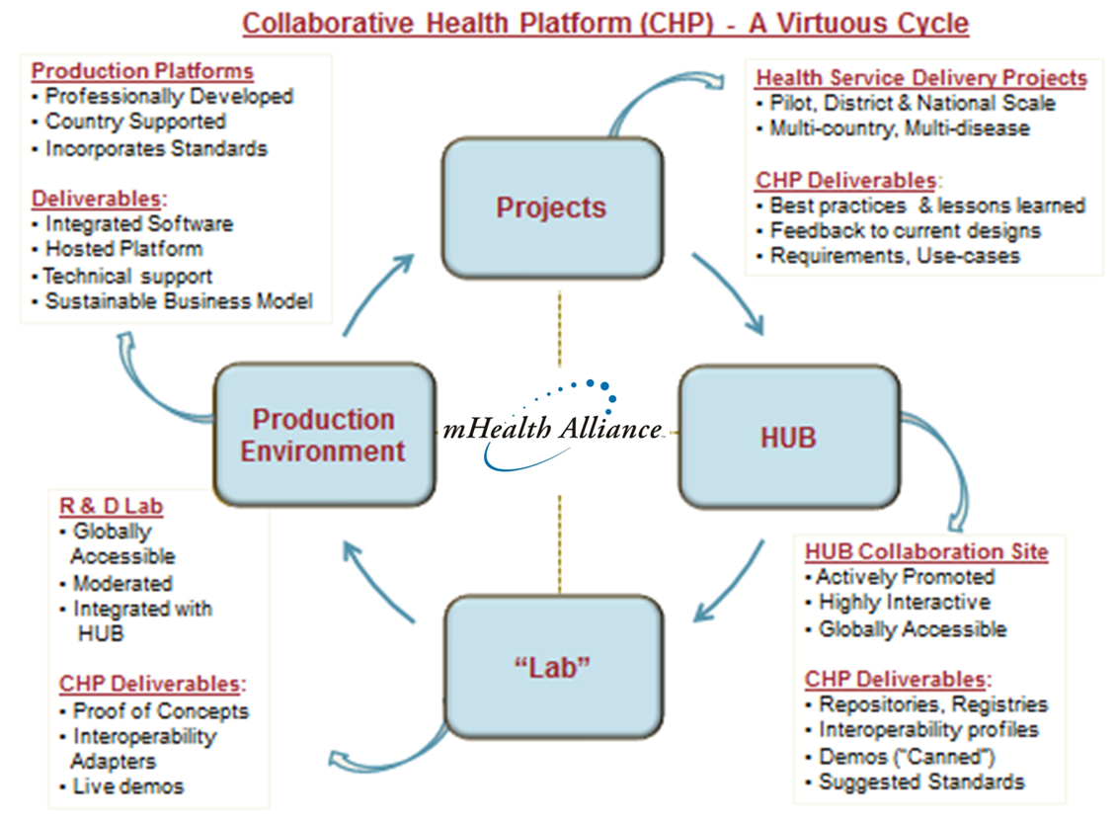

Source: Collaborative Health Platform Working Paper (Greentree, 2011)

The mHealth Alliance will play a facilitating role in this collaborative effort; quite literally it will provide the HUB for this virtuous circle. Shared assets, such as the *me*Health Framework and the NetHope-led engineering effort, will be curated by the Alliance on the HUB website. Labs, such as the HEAL in South Africa and Mohawk College in Canada, will be able to leverage these shared assets to prototype implementable solutions and develop software tooling. Public-private partnerships can host implementable solutions developed in the lab to support projects. Multiple projects on the ground can leverage shared, hosted *me*Health infrastructure to support interoperability and continuity of care. Lessons learned from the projects can be fed back into the designs, improving the commons for the next iteration around the virtuous circle.

# Overview and Context

## The Scope of the Problem

The Millennium Development Goals (MDGs) are eight international development goals that all 192 United Nations member states and at least 23 international organizations have agreed to achieve by the year 2015. Three of the MDG targets pertain to the health and wellbeing of mothers, babies and children.

The trend estimates available for maternal mortality indicates the lack of sufficient progress towards Target A of MDG 5, which seeks a 75 per cent reduction in the maternal mortality ratio between 1990 and 2015. Given that the global maternal mortality ratio stood at 430 per 100,000 live births in 1990, and at 400 deaths per 100,000 live births in 2005, meeting the target will require more than a 70 per cent reduction between 2005 and 2015.



Source: UNICEF State of World’s Children Report, 2009

The UN Foundation’s mHealth Alliance (mHA) has commissioned the development of a Maternal, Newborn and Child Health (MNCH) framework to leverage information and communications technologies (ICT) to help accelerate the progress of achieving these MDG targets. It is imperative that progress be made. As a stark comparator, the lifetime risk of maternal mortality ranges from 1 in 47,600 for a mother in Ireland, to 1 in every 7 in Niger, the country with the highest lifetime risk of maternal death.

Successfully achieving the MNCH-focused MDGs will require acceleration. Although some regions have been able to further their work in addressing the MDGs – overall, there is a very real danger the MNCH-related goals will not be met. ICT can be leveraged to: improve the efficiency, scope and reach of care delivery services; expand the capability of ministries of health to deliver educational information to citizens and to healthcare workers; increase adherence to evidence-based care plans and protocols. It is expected that, by leveraging ICTs in these and other ways, it may help accelerate the progress of national organizations as they strive to meet their MDG targets.

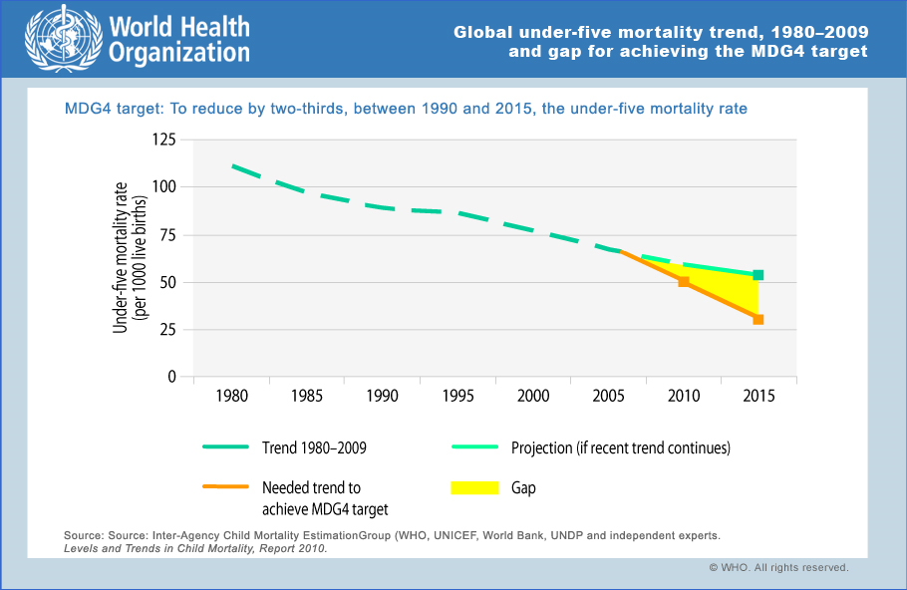

Source: WHO Global Health Observatory: MDG 4 (<http://www.who.int/gho/child_health/en/index.html>)

## Realities… and implications

### Reality #1 – ICT is a key component

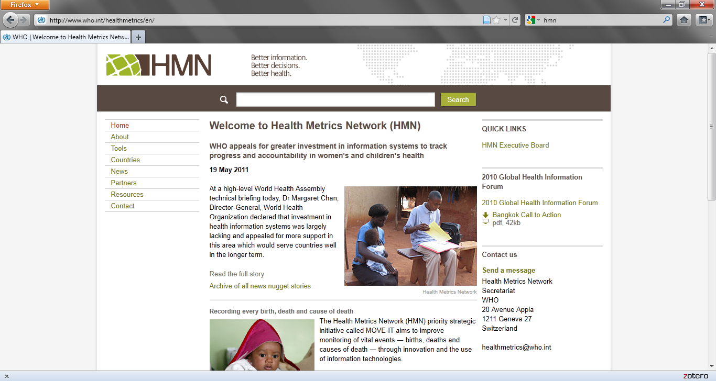

Source: Health Metrics Network

There is an adage: you cannot manage what you cannot measure. The WHO’s Health Metrics Network (HMN) has developed an entire analysis framework designed to help ministries of health in developing countries collect and analyse reportable metrics so they can begin to plan for and deploy the interventions that will be most impactful1-3. ICT plays a fundamentally important role in providing the data needed for health system management.

ICT is also a key mechanism for improving the efficiency and effectiveness of care delivery. Paper-based systems are often insufficient to support information sharing and care coordination and this impedes the ability to accelerate progress against MDGs 4, 5 and 6. Indeed, leveraging ICT in care delivery opens the opportunity to then de-identify and aggregate transactional data to provide the summary statistics and reportable metrics needed for health system management.

### Reality #2 – mHealth is the way to achieve REACH and SCALE in the developing world



Source: ITU Statistics for Africa, 2009

If ICT is a key to accelerating progress on MDGs 4, 5 and 6, then mHealth must be considered a key to rolling out ICT solutions in the developing world. ITU statistics (shown for Africa, above) clearly indicate that conventional (landline) solutions do not enjoy the levels of adoption that would allow them to support a broad deployment of ICT solutions. In order to achieve true scale, mobile phone based solutions will need to be employed.

### Reality #3 – The status quo will not lead to success

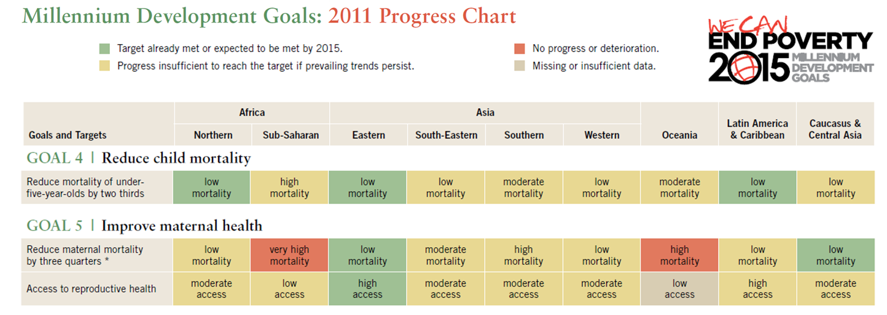

Source: UN MDG Progress Chart 2011

The present course of action is not working; we have been unable to “move the big dot” (a term coined by the Institute for Healthcare Improvement to describe the making of an order-of-magnitude improvement) on the healthcare related MDGs. Some are suggesting that this is not because more resources are needed behind the current strategy, but rather because the current strategy needs to be revisited.4-8

### Reality #4 – The “medical model” of care is not a viable option for developing countries

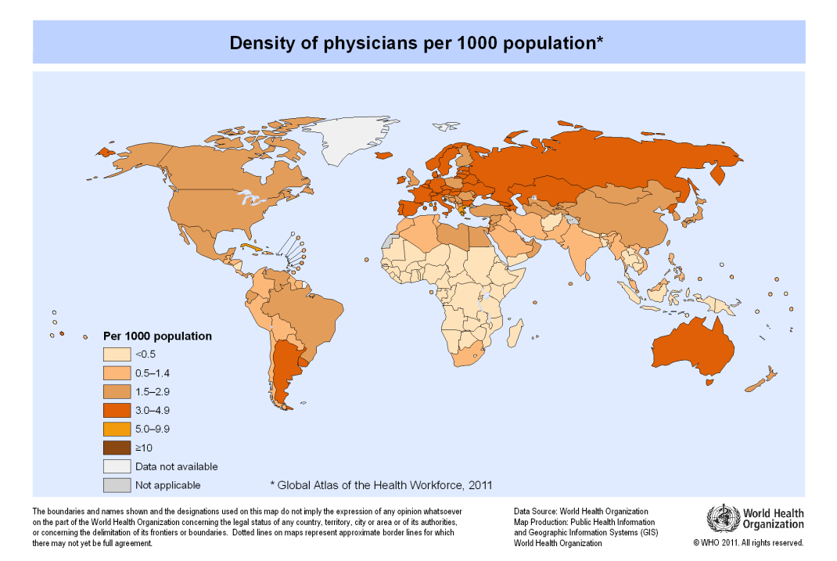

Source: WHO Global Health Observatory Map Gallery

Many high income countries have developed hospital-centric systems. Even in these very wealthy, well-funded environments, there is evidence that such an approach leads to expensive, reactive, sick-care systems which underperform compared to preventive, proactive, *health*care systems – even though the latter is a less expensive option.9,10 In developing countries, the western (high income country) medical model must be foregone in favour of a holistic, community-based approach focused on primary care.

## The Importance of a Systems Approach

The *me*Health Framework project embraces the view that the key to successfully impacting health outcomes lies in strengthening universal access to primary care. This is true for maternal, newborn and child care; indeed, it is true for healthcare in general and is the right strategy regardless of a country’s wealth. Although it is clear that, in many developing countries, there needs to be more money for healthcare – it is equally important that an efficient, systems-based approach is employed so that in these low-resource environments we can deliver more healthcare for the money.

The balance of this section is focused on describing a set of health system strategies cognizant of the realities listed previously.

### Strategy: Universally Accessible, Person-centric, Primary Care

The 1978 Declaration of Alma Ata posited that the key to improving healthcare in developing countries is to strengthen primary care. Thirty years later, the WHO’s 2008 World Health Report: Primary Health Care Now More Than Ever11, describes three particularly “worrisome trends” that undermine the ability to delivery equitable, effective healthcare:

1. health systems that focus disproportionately on a narrow offer of specialized curative care;
2. health systems where a command-and-control approach to disease control, focused on short term results, is fragmenting service delivery;
3. health systems where a hands-off or laissez faire approach to governance has allowed unregulated commercialization of health to flourish.

Although these worrisome trends are expressed in negative terms in the WHO report, the strategy which arises and which is embraced by the present proposal may be expressed in positive ones.

1. A health system focused on a generalized, coherent, continuity of care rooted in a strong portfolio of services offered at the primary care level.
2. A holistic, person-centred (rather than disease-centred) healthcare approach.
3. Universal access to a defined portfolio of healthcare services paid for out of a pre-paid (insurance) model.

There is overwhelming evidence that a healthcare system characterized by the three attributes listed above provides the highest level of health outcomes per dollar invested4,11-15. For this reason it is preferred.

### Strategy: Task-Shifting

Many low resource environments suffer a chronic shortage of skilled clinicians. The shortage imperils the ability to succeed with a primary care focused approach. There is evidence that a strategy of task-shifting to community health workers (CHWs) can help alleviate such a situation, but with a number of important caveats:

1. Quality-of-care must be maintained
2. Adherence to care guidelines must be made systematic
3. Effective management must be provided.16-18

This should not be considered only a short term or stop gap strategy. Community health workers can and should be part of a strengthened primary care service over the long haul. This CHW pool, however, cannot be thought of as clinical care delivery for free; it is not that. As part of the longer term strategy, there must be a mechanism to compensate CHWs (whether this is through monetary or other valuable, but non-monetary mechanisms). There also must be a mechanism to educate this group both during the initial indoctrination process and on an ongoing basis.

### Strategy: Evidence-based Guidelines

Studies have definitively shown that strong adherence to evidence-based care protocols improves health outcomes4,7,10,11. The caveats around the strategy to leverage CHWs clearly call for the adoption of care guidelines by the healthcare system. This is crucial if task shifting is to be successful. Indeed, it is crucial across the entire continuum of care and should be embraced by both non-clinical and clinical participants in the system.

Much work has been done regarding guidelines and a significant set of evidence based care plans are available from WHO19. These may be used by ministries of health as a starting point and altered, as necessary, by national ministries of health to reflect local conditions, strategies, policies and priorities.

### Strategy: Health System Management

How is this a strategy and not a platitude? The strategic element is to delineate that the national health system is the *system*. This simple and somewhat obvious statement has fundamental implications. These implications are succinctly expressed by the OECD’s summary of the five core principles of the Paris Declaration20:

*It is now the norm for aid recipients to forge their own national development strategies with their parliaments and electorates (****ownership****); for donors to support these strategies (****alignment****) and work to streamline their efforts in-country (****harmonisation****); for development policies to be directed to achieveing clear goals and for progress towards these goals to be monitored (****results****); and for donors and recipients alike to be jointly responsible for achieveing these goals (****mutual accountability****).*

What then are the implications of this strategy? The implications are that care delivery activities conducted in country, by whatever party, will be consistent with national healthcare mandates and be able to provide reportable metrics in a form which the national ministry of health can consume and make use of. Such a strategy establishes that there will be explicit guidelines regarding which software applications and services are needed to fulfill national healthcare mandates. It would follow that there would be equally explicit guidance regarding how these applications and services will “plug in” and interoperate with the overall healthcare system they serve.

## The Role of *me*Health

Quite simply, the role of *me*Health is to tactically support the strategies described in the previous section. In this section, we define *me*Health and describe a number of tactics which may be employed in the face of such an ICT framework.

### Defining *me*Health

The term eHealth is defined by the WHO as “the use of information and communication technologies (ICT) for health.” This very broad and encompassing definition supports the use ICT in support of diverse activities including clinical care delivery, health promotion, disease prevention, and health system management.

WHO indicates that “Mobile Health (mHealth) is an area of electronic health (eHealth) and it is the provision of health services and information via mobile technologies such as mobile phones and Personal Digital Assistants (PDAs).” The importance of employing mobile technologies, especially mobile phones, is starkly illustrated by statistics from the International Telecommunications Union (ITU) which show that mobile phones are by far the most prevalent ICT in developing countries (note the chart shown above as part of “Reality #2” which illustrates mobile phone adoption in Africa).



The term *me*Health has been adopted in this draft report as a term that embodies three important elements:

1. Mobile phone technologies, mHealth, will be leveraged as the predominant ICT “edge-of-the-network” devices supporting health promotion, education, and community based care delivery in developing countries.
2. Enterprise-level, “cloud-based” eHealth infrastructure will support shared health record repositories and provide care coordination over time and across multiple care delivery sites.
3. The combination of mHealth and eHealth technologies, in addition to providing important indicators and statistics for health system monitoring and management, will support **person-centred care**.

The *me*Health Framework leverages the power of centralized, highly available, enterprise-level infrastructure which may be accessed and leveraged using inexpensive, pervasive mobile devices. These infrastructure elements, together referred to as *me*Health, will be leveraged to provide person-centred care that can be scaled to serve entire populations.

### Tactic: Employ ICT to Improve Efficiency and Effectiveness

A key, overarching assumption is that a primary role for ICT is to improve the efficiency and effectiveness of data management and data processing, as compared to manual, paper-based processes. Here it is important to note that efficiency is measured as a system metric not a task metric. This reflects the fact that, in some cases, a particular task may take longer using ICT than it would take using paper-based processes – but the overall system effort is reduced when downstream data management and data processing tasks are also considered. Likewise, the effectiveness of a process (in terms of timeliness, process quality, data quality, ability to support decision-making, etc.) is improved when the number of touch points are reduced and when data re-entry is minimized.

Efficient, effective workflow processes may be coupled with a targeted portfolio of interventions to drive down the per capita cost of universal healthcare. Indeed, a number of low income countries (LICs) have developed and implemented universal healthcare systems at per capita cost points that are fundamentally lower (90% lower) than the OECD average.13

### Tactic: “Systematize” Standard Care Processes

Community-based care is a key strategy. However, there are issues that, unless addressed, would hamper the success of such a strategy. The consistency and quality of CHW-delivered care is sometimes poor. In addition, the management and supervision of CHWs is often inadequate.18

Continuous training techniques, such as the delivery of daily SMS “job aids” to a CHW’s mobile phone, have been shown to systematically improve CHW competency and knowledge.5,17,18 Educational information, medication reminders, and appointment reminders have also been shown to improve client adherence to care guidelines. In support of direct care delivery, a number of software offerings are today able to embed rigorous, evidence-based care guidelines into CHW’s mobile phone-based workflows. Embedding the care workflow into the application software reduces the training time needed for a CHW to be effective in care delivery and increases adherence to best practices. Importantly, such programs also provide performance data which may be employed to strengthen CHW supervision and management.

### Tactic: Deploy Shared Infrastructure for Healthcare

The *me*Health infrastructure needed to support community-based MNCH workflows is no different from the *me*Health infrastructure necessary to generally support primary care, referral centres, hospitals, labs, medication management and the rest of the entire healthcare system. Indeed, a shared *me*Health infrastructure may be considered a key mechanism to make progress towards improved both care delivery *and* more comprehensive and timely reportable metrics.

In the face of a shared infrastructure, a diagonal approach towards health system strengthening may be embraced.21 The proposed *me*Health Framework does not expect to unseat the many IT systems and point solutions supporting existing vertical programs or points of service. Rather than a “rip and replace” approach, the *me*Health Framework proposes an “embrace and extend” approach which will leverage successful IT initiatives as key components of an overall, national healthcare information system. Such a tactic is enabled through deploying an overarching infrastructure that facilitates the sharing of person-centred information between disparate, heterogeneous IT systems. This infrastructure would mediate collaboration between these systems and thus avoid the daunting “permutations and combinations” challenge of having to establish and maintain many-to-many system connections.

### Tactic: Generate Reportable Metrics From ICT-supported Care Activities

In May 2011 the United Nations Commission on Information and Accountability for Women’s and Children’s Health presented their report, Keeping Promises, Measuring Results22, which included recommendations to increase the likelihood that pledges for women's and children's health are honoured and that resources are spent in the most effective way to save lives. The first five of the commission’s ten recommendations addressed the need for improved reporting of healthcare system metrics:

1. increasing the number of countries with well-developed systems to measure births, deaths and causes of deaths;
2. measuring against 11 common indicators on reproductive, maternal and child health;
3. helping countries integrate the use of Information and Communication Technologies in their national health information systems;
4. countries with high maternal and child deaths track and report resource indicators;
5. country governments and major development partners put "compacts" in place that require reporting, based on country format, on externally funded expenditures and predictable commitment.

The proposed *me*Health Framework supports the ability to mine reportable statistics from the transaction histories of care delivery events. In this way, ICT-supported care delivery will also generate the information so important to effective health system management. Doing so will strengthen the ability of ministries of health to appropriately allocate resources and develop initiatives and programs that will impact health outcomes for their citizens. It will also help provide important audit trails for donors and reportable indicators for WHO and other global bodies.

### Tactic: Seek Innovative Ways to Fund Universal Healthcare

The important role played by mobile phones in the overall *me*Health strategy holds the potential to leverage innovative business models for health system financing. Mobile Network Operators (MNOs) in developing countries, unlike their counterparts in many high-income countries, do not consider themselves to be solely in the “phone” business. For instance, fewer than 5% of Africans have a bank account. MNOs in sub Saharan Africa have stepped up to provide banking services and even micro-insurance services through the client’s mobile phone.23

Any funding scheme for universal healthcare relies on mechanisms to broadly spread the costs of health insurance among those who can pay so that those who cannot pay may be afforded healthcare services as well.5,24,25 In most high-income countries, mandatory insurance, payroll tax or general income tax schemes are successfully able to create a large enough pool of payors to fund universal healthcare. In many developing countries, the grey economy can be on the same order as the “taxable” economy (or even larger!). In these economies, it is not possible to look to the tax base to provide a large enough pool to effectively provide insurance. Instead, it may be more worthwhile to investigate creative mechanisms to partner with MNOs to sustainably fund universal healthcare. In most developing countries, the MNOs represent the single largest pool of potential payors in the country.

Of course, no sustainable funding solution will be viable unless it is possible to unambiguously identify who it is that is the recipient of care services. As important as such a capability is for supporting person-centred care, it is equally important for supporting the financial transactions that are associated with care delivery services. Here again, growing mobile phone adoption provides important opportunities.

There are three accepted factors for authentication: something you *have*, something you *know*, and something you *are* (biometrics). A mobile handset’s SIM card is a globally unique identifier. This means that a mobile phone (something a person HAS) coupled with a PIN (something a person KNOWS) or with a voice print (something a person IS) would be able to support robust, two-factor authentication – even in situations where phones are shared. Such techniques are already being employed to support mBanking and should be leveraged within a healthcare context.26

# Describing the Framework

## An Enterprise Architecture for *me*Health

### What is Enterprise Architecture?

Although it is a term which causes some to have an almost allergic reaction, it can be said that the *me*Health Framework describes an Enterprise Architecture (EA) for healthcare. The US National Institutes of Health define EA as follows:

Enterprise architecture is a comprehensive framework used to manage and align an organization's Information Technology (IT) assets, people, operations, and projects with its operational characteristics. In other words, the enterprise architecture defines how information and technology will support the business operations and provide benefit for the business.27

It is useful to think of EA as analogous to city planning. In city planning, building structures that are to be constructed adhere to municipal guidelines so they do not ruin the flow of traffic and/or overwhelm the available city resources. New buildings must be able to plug into common, shared assets like the electrical grid and the water and sewer systems. If a building did not follow the city plan, it would need to construct its own road, set up its own power generator, drill its own water well and install its own septic system. Likewise, it is through EA that enterprise systems become civilized so they can efficiently interoperate, scale and grow.

The *me*Health Framework makes use of a standards-based approach to define and describe its EA.



Source: Wikipedia (<http://en.wikipedia.org/wiki/RM-ODP>)

An overall enterprise architecture may be fully defined by describing it using five different viewpoints:

1. **Enterprise Viewpoint** – focuses on the purpose, scope and policies for the system. It describes the business requirements and how to meet them.
2. **Information Viewpoint** – focuses on the semantics of the information and the information processing performed. It describes the information managed by the system and the structure and content type of the supporting data.
3. **Computational Viewpoint** – is concerned with the functional decomposition of the system into a set of objects that interact through formalized interfaces. It describes the puzzle pieces that deliver the system’s functionality and the way those pieces interact with each other.
4. **Engineering Viewpoint** – is concerned with the infrastructure required to support system implementation and distribution.
5. **Technology Viewpoint** – is concerned with the choice of technology to support system implementation and distribution.

The *me*Health Framework which is the subject of this document is described using the first three of these: Enterprise Viewpoint, Information Viewpoint and Computational Viewpoint. The Framework is not prescriptive regarding the specific infrastructure or technology stack that a particular *me*Health system employs – and it does not need to be. The goal of the Framework is to achieve interoperability between *me*Health solutions that are based on it. Systems built using different topologies or different technologies (e.g. C# and SQLServer vs. Java and MySQL) can achieve interoperability as long as their Enterprise, Informational and Computational viewpoints are consistent with each other.

### Describing the *me*Health EA Viewpoints

The Enterprise Viewpoint (EV) for the *me*Health Framework describes the care delivery workflows and functions that characterize the healthcare system. As per the scope of work outlined by the mHealth Alliance for this work item, the functional profiles employed to develop use cases for the *me*Health Framework’s EV are those that apply to maternal, newborn and child health (MNCH).

Happily, the use cases that support MNCH are consistent with generic use cases which would be used to support a number of other care scenarios. It is expected that, although motivated by the care requirements for MNCH, the functionality described in the EV will be generally applicable. The EV is expressed through a set of characteristic use case stories, which personify specific care delivery use cases, and associated workflow diagrams (which follow the Business Process Model and Notation, or BPMN, standard).

The Information Viewpoint (IV) is related to the EV; the IV answers the question: what information is needed to drive the use cases documented by the EV? This information is broken down into data objects, or classes, and expressed using the Unified Markup Language (UML) standard for Class Diagrams. Wherever possible, standards-based data specifications have been leveraged and referenced.

The Computational Viewpoint (CV) answers the question: which participants in the workflow must exchange the information documented in the IV, and how is that “conversation” conducted? The CV is documented using the UML standard for Sequence Diagrams. As the name implies, Sequence Diagrams describe the sequence of information exchanges between workflow participants.

## A Functional Profile for MNCH

A functional profile describes, at a top level, what a system does. For this *me*Health Framework, the functional profile is based on those interventions listed in the WHO’s definitive document: *Every Woman Every Child* (EWEC), which can be supported by ICTservices. This necessarily excludes interventions which may be characterized as healthcare policy development or direct clinical activities but includes activities such as:

* Population education and promotion of care-seeking
* Health worker education
* Formalization, codification and operationalization of evidence-based care plans and referral triggers
* Support for continuity of care, across care settings and over time, through workflow choreography, inter-organizational orchestration, and health information sharing.

The scope of this MNCH-focused Framework, therefore, is to leverage ICT (*me*Health infrastructure) to educate, to codify evidence-based practices and make these available to subjects and providers of care, and to share health information to support both person-centred care delivery and health system management.

The full range of EWEC interventions is described in the 2010 WHO document: Packages of Interventions for Family Planning, Safe Abortion care, Maternal, Newborn and Child Health. At a summary level, the EWEC interventions are divided into 7 categories:

1. Family Planning
2. Safe Abortion Care
3. Pregnancy Care
4. Childbirth Care
5. Postpartum Care of the Mother
6. Care of the Newborn
7. Care during Infancy and Childhood



Source: Packages of Interventions for Family Planning, Safe Abortion care, Maternal, Newborn and Child Health, WHO (2010)

In each category, the package of evidence-based interventions and the resources needed to effect the intervention are listed. These interventions are identified as applying at the Home/Community level, the First Level Health Facility, or at the Referral Facility. Mapping these interventions to *me*Health, the following functional profile may be developed:

### Family Planning

Deliver population-targeted educational information to increase awareness of the benefits of safe sex, family planning and birth spacing

Deliver health worker-targeted educational information to increase awareness of the signs of domestic and sexual violence

Support evidence-based case management and referral of couples seeking fertility services, HIV counseling (including for HIV discordant couples), and cases of domestic and sexual violence

Support lab test ordering and results delivery

Support medication ordering and dispensing

### Safe Abortion Care

Deliver population-targeted educational information to increase awareness of sexual and reproductive health including: unwanted pregnancy, coerced sex, consequences of unprotected sex, legal grounds for safe abortion, consequences of unsafe abortion, availability of family planning services, availability of pregnancy detection and safe abortion services

Support evidence-based case management and referrals for abortion services and instances of abortion-related complications

Support lab test ordering and results delivery

Support medication ordering and dispensing

### Pregnancy Care

Deliver population-targeted educational information to increase awareness of self care at home, nutrition, safer sex, HIV, breastfeeding, family planning, healthy lifestyle including harmful effects of smoking and alcohol use, and use of insecticide treated bed nets

Deliver health worker-focused training and job aids re: evidence-based care protocols, rudimentary assessment criteria, etc.

Enroll pregnant women in an antenatal care plan

Support evidence-based scheduling, including:

* Client reminders regarding ANC visits
* CHW reminders regarding ANC visits
* Medication reminders (e.g. PMTCT, antimalarial intermittent preventive treatment, etc.)
* Reminders regarding birth planning

Support the collection of appropriate clinical and situational data and the guided delivery of evidence-based services at each ANC appointment

Support referrals in cases of pregnancy complications or where specialized treatments are warranted

Facilitate telemedicine support for health workers

Support lab test ordering and results delivery

Support medication ordering and dispensing

### Childbirth Care

Support transportation scheduling

Facilitate telemedicine support for health workers

Support emergency referrals in the case of complications during childbirth or during the immediate postpartum period

Collect reportable metrics, including birth and death statistics

Support lab test ordering and results delivery

Support medication ordering and dispensing

### Postpartum Care

Deliver population-targeted educational information to increase awareness of exclusive breastfeeding, birth spacing, the importance of rest and reduced workload, and danger signs including postpartum depression

Deliver health worker-focused training and job aids re: evidence-based care protocols, postpartum assessment, etc.

Support evidence-based case management including maternal records maintenance, vital statistics logging, care delivery and monitoring, medication management, and referrals

Facilitate telemedicine support for healthcare workers

Support lab test ordering and results delivery

Support medication ordering and dispensing

### Newborn Care

Deliver population-targeted educational information to increase awareness of thermal protection of the newborn, general hygiene, cord care, safe disposal of baby’s feces, newborn stimulation and play

Support evidence-based case management including scheduling of routine follow up visits, data collection, child immunization, child’s health records, PMTCT protocol adherence, etc.

Facilitate telemedicine support for health workers

Support lab test ordering and results delivery

Support medication ordering and dispensing

### Infancy and Childhood Care

Deliver population-targeted educational information to increase awareness of nutrition, general hygiene, signs of illness and timely care-seeking

Support evidence-based case management including scheduling of routine follow up visits, data collection, child immunization, child’s health records maintenance, and referrals

Facilitate telemedicine support for health workers

Support lab test ordering and results delivery

Support medication ordering and dispensing

### Reportable Metrics

At some future point, it may be assumed that healthcare transaction data will exist for a significant majority of maternal, newborn and child cases. Between now and then, the transactional data captured using the MNCH Framework will represent a sampling of the overall population which may be extrapolated. By harvesting de-identified case management and clinical transaction data, statistics may be developed regarding the following reportable metrics listed in EWEC:

* Hospitalization rate for unsafe abortion per 1000 women, age disaggregated.
* Maternal death ratio attributed to abortion, age disaggregated.
* Percentage of pregnant women receiving antenatal care by skilled personnel at least once during pregnancy.
* Percentage of pregnant women receiving antenatal care by skilled personnel at least four times during pregnancy.
* Percentage of pregnant women who have been tested for HIV and screened and treated for syphilis.
* Percentage of HIV positive pregnant women who have received ARVs for PMTCT.
* Percentage of pregnant women who are fully immunized against tetanus.
* Percentage of births attended by skilled health personnel.
* Percentage of births in facilities.
* Percentage of all births by Caesarean section.
* Maternal mortality ratio, age disaggregated.
* Perinatal mortality rate.
* Percentage of women discharged from facilities in less than 24 hours after childbirth.
* Percentage of women receiving postpartum care within 7 days after childbirth.
* Percentage of women using a modern method of contraception at 6 weeks after childbirth.
* Neonatal and early neonatal mortality rates.
* Percentage of newborn infants put to the breast within 1 hour of birth (DHS, MICS).
* Percentage of newborns receiving postnatal care visit within 2 days of birth (DHS, MICS).
* Early neonatal deaths (within 7 days) of babies weighing 2500g or more in facilities.
* Percentage of infants under six months exclusively breastfed.
* Percentage of one-year-old children immunized against measles.
* Percentage of children 0-59 months with diarrhoea who received oral rehydration therapy and/or increased fluids, with continued feeding.
* Percentage of children 0-59 months with signs of pneumonia who received an antibiotic.
* Infant and under 5 mortality rate.
* Percentage of children 0-59 months who received antimalarial treatment within 24 hours of onset of fever.
* Percentage of HIV-infected children 0-5 years receiving lifelong antiretroviral therapy.

The development of many of these metrics is confounded by the challenges of determining a value for the denominator. In many if not all instances, however, the data that *is* collected through *me*Health transactions can be used, along with other sources, to estimate denominators that are statistically significant.

## Unpacking the MNCH Functional Profile

The MNCH-focused functional profile that arises from the WHO’s Every Woman, Every Child packages of interventions may be analyzed and generalized to yield the following actors, settings and activities.

### Actors

Subject of Care

* Adult subject of care
* Dependent (child) of adult subject of care
* Spouse / partner of adult subject of care

Provider of Care

* Community Health Worker (CHW)
* CHW Manager
* Health Worker
* Clinician
* Physician
* Nurse Practitioner
* Nurse
* Pharmacist
* Lab Technician
* Allied Health Professional
* Implied: Health system manager

### Settings

Primary Care

* Home / Village
* Health Outpost
* Health Centre
* Primary Hospital

Secondary Care – Hospital

Tertiary Care – Hospital

### Activities

Deliver population focused information (general “broadcast”)

Deliver client focused information (person specific)

Deliver healthcare provider focused information (general)

Deliver healthcare provider focused information (client or provider specific)

Order lab tests

Report lab test results

Order medications

Dispense medications

Enroll client in care management program

Deliver care as per care plan

Collect and report data

Refer clients

Provide telemedicine support

Implied: Health system management and administration

* Enroll care providers and assign access privileges
* Generate and report aggregated metrics
* Support health system funding/payments

## Describing the Viewpoints

Use Case Stories are an effective means of describing functional requirements. Simple scenarios will be employed to help express the Enterprise Viewpoint (EV) in terms which personify the Actors and contextualize the Activities and their Settings. Each story brings into focus the implications regarding meHealth infrastructure necessary to support the scenario.

### Use Case Story Characters

The following characters will participate as actors in the use case stories:

* Mosa is a young pregnant woman with 2 small children. She lives in a rural village in sub Saharan Africa. She has access to a mobile phone which is shared among members of her extended family. Mosa is not illiterate.
* Benjamin is Mosa’s husband. Benjamin is literate.
* Grace is a community health worker (CHW) who works in Mosa’s village.
* Sarah is Grace’s CHW Manager
* Joshua is the nurse at the local Health Centre
* Marion is the physician at the Referral Centre (HOSPITAL)
* Samuel is a lab technician at a regional lab (LAB)

### Use Case Story Settings

Benjamin and Mosa have a small home in their village; Grace often visits Mosa at their home. There is a Health Centre in a nearby village (2 hrs walking) and a Referral Centre (a Primary Hospital) at a large town in the district (12 hrs walking, 1 hr by vehicle). The Health Centre is a first level facility that has birthing rooms and a medicines store room; Joshua and Sarah both work there assisted by a number of health workers.

The Referral Centre has a physician, Marion, and is equipped to handle obstetric emergencies. Housed in the same building as the Referral Centre is a regional lab where samples are sent for processing; Samuel works at the regional lab.

### Workflow Diagrams

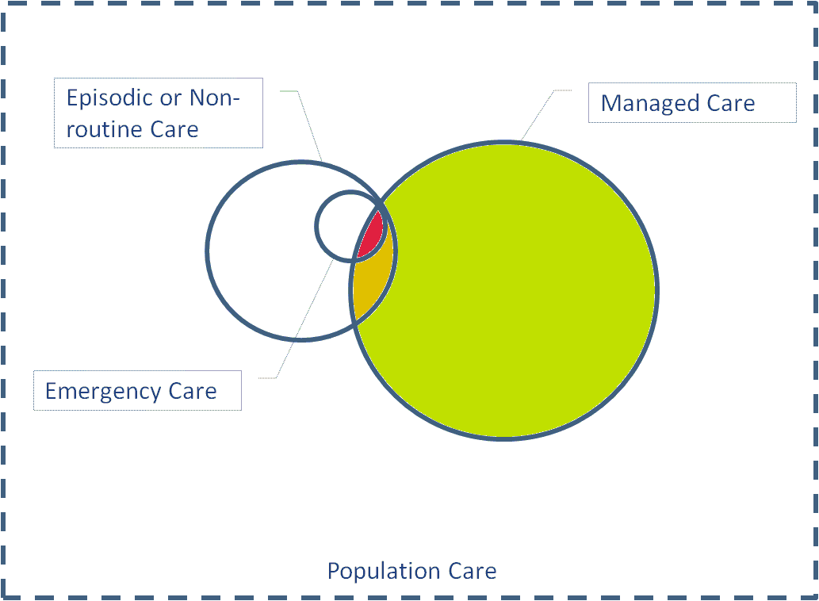

An Illustration of Care Populations

Because of its defined scope, the workflow diagrams in this framework are specifically focused on care that is delivered:

* to mothers, newborns and children receiving routine care as per a set of defined, evidence-based care guidelines (shown in green)
* to members of the managed care population who, for a variety of reasons, are escalated from routine care to non-emergency care (shown in yellow)
* to members of the managed care population whose care is escalated to emergency or referral care (shown in red)

The managed care population is a subset of the overall system of public or population focused healthcare. It is expected that our MNCH population of interest would benefit from initiatives deployed on behalf of the population as a whole and, conversely, would be impacted by shortcomings in this overall system.

The workflow diagram format is generally based on the format favoured by the Collaborative Requirements Definition Methodology (CRDM) and employs simplified BPMN 2.0 constructs.

The use case stories that describe the Enterprise Viewpoint are illustrated using workflow diagrams where the “swim lane” is indicative of the care populations as described above (and generally following the format used in EWEC). The “green lane” indicates routine processes; the “yellow lane” is for escalated processes that do not require referral and the “red lane” indicates escalation to a referral location.

To this basic form, three other lanes have been added to illustrate the invoking of support, local ICT and shared ICT services. The six swim lanes are described as follows:

#### Support Services

This lane is used to represent support services external or ancillary to the core workflow being documented. These might include diagnostic imaging and lab testing, medications management and dispensing (where this is not done from the care facility) and the supply chain management activities that support these services. *NOTE: when these services are themselves the subject of a core workflow, the activities would be documented in the “Routine Care” lane.*

#### Escalated Referral Care

This lane indicates care that has been escalated and referred to a Referral Centre (as defined in EWEC) or to any of the secondary or tertiary hospital facilities to which care could be escalated.

#### Escalated Non-referral Care

This lane indicates a care process that has been flagged as non-routine, but which does not yet warrant referral.

#### Routine Care

This lane indicates routine care which is being delivered as per guidelines in the appropriate care settings.

#### Local ICT

This lane indicates information processing which is done at a point of care. The ICT device might be a mobile phone or a computer at a facility. The distinction is that the processing is being done by the local device on data that resides on the local device.

#### Shared ICT

This lane indicates hosted (cloud based) processing and data services. This would include SMS-based or voice-based educational information dissemination, alerts/reminders, shared health record services, DHIS indicator reporting, HMIS analytics, etc.

### Sequence Diagrams

A UML sequence diagram shows the interaction between participants in a workflow. In the following section, the Computational Viewpoint (CV) of the architecture is described using sequence diagrams. Sequence diagrams have been developed to illustrate the use case stories described in the EV. Following these diagrams, a set of generic diagrams are presented which illustrate the archetypal patterns that have emerged and which, in aggregate, provide a catalogue of the system interactions necessary to support the *me*Health Framework for MNCH.

The diagrams developed for this report were constructed using the online tool available at [www.websequencediagrams.com](http://www.websequencediagrams.com). This interactive, online UML diagramming tool is driven by a pseudocode that is readily understood by human readers. For each of the following use cases, the pseudocode, the resulting diagram and a detailed discussion will be included.

### Information Models

The overall Information model for the *me*Health Framework is informed and influenced by part 2 of the Health Information Service Architecture (HISA) standard (ISO 12967-2), Information Viewpoint. A top level view of this general model is shown below.



Source: Informed by ISO 12967-2

Following is a discussion of the information model and its implications for data interoperability.

* Healthcare providers are a generalization of individual users; individual users may have specific authorizations to access clinical information. As a simplification, access authorities may be associated with provider types (roles).
* For interoperability, each healthcare provider must be uniquely and unambiguously identified with an enterprise provider ID (EPID). In order to support provider discovery and appropriate health human resource management, provider capabilities (e.g. nurse, physician, CHW) need to be described using a standardized code system.
* Providers execute care activities on behalf of subjects of care. Such activities may consume or utilize resources (including facility-based assets). Care activities are related to care plans which are person-specific and based on clinical guidelines.
* System interoperability will require that subjects of care are uniquely identified with an enterprise client ID (ECID) and that facilities are uniquely identified with an enterprise location ID (ELID). Where there is an established primary care relationship, the provider’s EPID should be noted in the client record.
* To support facility discovery and appropriate referral routing, each ELID must have associated with it a geocode (a longitude and latitude pair for global geographic positioning) and a list of the clinical services it supports; these services (such as x-ray, emergency obstetric care, etc.) must be coded using a standardized code set.
* Care guidelines should be uniquely identified. Clinical activities which are in response to or in satisfaction of a care guideline should reference the guideline.
* Activities that are undertaken at a facility, by a provider, on behalf of a client must reference the ELID, EPID and ECID that reflects that relationship and log the timestamp of the activity. Prospective activities may reference a future date. The permanent record of an activity must be uniquely identified; it may be assigned a globally unique ID (GUID) if the combination of IDs plus timestamp cannot be relied upon to be unique.
* A subject of care has contact with the care delivery system over the course of a period of care. The period of care is determined by the subject of care’s particular health issue.
* Clinical information regarding the subject of care is developed by health providers; this information is longitudinal and therefore may be developed by multiple providers and related to multiple health issues.
* Clinical information that arises from a care activity must reference the activity’s ID. By implication, this means clinical information that results from an activity must reference and uniquely identify the author, subject and location.
* The author and subject of clinical information must be identified (reference EPID and ECID). For interoperability, clinical observations, diagnoses and care plans must be uniquely coded using a standardized code set.

There are a number of areas where the HISA model is not a precise fit:

* Individual subjects of care can also have system access and, in this case, would also enjoy system access privileges through an authorization profile. The HISA model only illustrates the case where providers are granted such privileges.
* There are activities that may be self-directed by the subject of care such as care or education-seeking. The HISA model is focused more on care delivery activities performed by providers.
* The HISA model does not contemplate personal health records or situations where subjects of care are maintaining clinical information within their own shared health record. The model is focused on the clinical information *about* the subject of care, *maintained* by providers.

A more detailed discussion of the Information Model follows in the section documenting use case stories.

# Use Case Stories

## Grace Enrolls Mosa to Receive *me*Health Information

### The Characters

The characters in this use case story are:

* Benjamin (husband) & Mosa (his pregnant wife)
* Grace, the local Community Health Worker (CHW)
* A data entry clerk who has access to a computer and is able to key in Mosa’s information and the information regarding her children
* An mHealth Service and a Shared ICT infrastructure which can be accessed by Grace’s or Mosa’s mobile phone

### The Story

This story is informed by the Mobile Midwife case study published by the Grameen Foundation.

Benjamin sees a poster in the village with information about a free service which provides health related information for pregnant women. Benjamin encourages Mosa to enroll in this service.

Mosa asks Grace about the service. Grace enrolls Mosa in the service.

Using the family phone, Mosa is able to retrieve recorded messages by “flashing” the service. When she flashes the service, the service calls Mosa back and begins an interactive voice response (IVR) menu system.

Using the IVR, Mosa authenticates herself to the service and the service provides pregnancy information specifically suited to Mosa’s conditions and the point she is at in her pregnancy.

If Mosa has an upcoming ANC visit or if there is other information which should be “pushed” to her, the service sends her a message. The message indicates to Mosa that she has “information waiting”. She retrieves the information using the same process she uses to “pull” information.

### meHealth Implications

* There must be a mechanism to enroll participants in the program.
* There must be a mechanism to uniquely identify Mosa over the phone.
* There must be a way to log events associated with or attributable to Mosa, including if she has previously listened to an educational message or an alert.
* There must be a way to describe a care plan for Mosa based on her conditions, on calculations of time or time interval, and on events which have (or have not) occurred.

### Workflow Diagram



Workflow Diagram: Information Dissemination

A generalized description of the Information Dissemination workflow described in the use case story is illustrated in the workflow diagram shown. This diagram may be generically described as follows:

* A predecessor step is to enroll the information recipient in the program. This is a routine process which may be executed by the client or by a CHW on the client’s behalf. It should be noted that the same process that is employed to enroll clients to receive information may also be used to enroll providers so that they may receive job aids and ongoing education.
* Information may be “pulled” by the recipient. A common process is for the information recipient to “flash” an information service using their mobile phone. The service can then call the client back (which makes information retrieval free to the client). An authentication process may be used to establish the identity of the recipient. An interactive voice response (IVR) system may be used to allow navigation through a menu of options. The information may be provided as a recorded voice message or by sending text messages via SMS. The information “pull” process may be initiated by the recipient at any time on an ongoing basis.
* Information may be “pushed” to the recipient. A voicemail or SMS service may be used to indicate that there is a waiting message. The recipient may be called directly by the service at a pre-determined time. When a recipient responds to the “message waiting” semaphore, the process is essentially the same as that described for “pull” message retrieval.
* For either the pull or push workflow, the process may include not only message dissemination but also interaction to obtain information from the recipient. For example, a message may be pushed to a client regarding a medication reminder. The reminder may ask the client to key in responses to questions that can be used to determine their adherence to their medication plan. Depending on the responses, follow on questions, or follow up actions may be pursued.

The generalized diagram shown above depicts, at a high level, support for the following activities from the functional profile:

* Enroll client in care management program
* Deliver population focused information (general “broadcast”)
* Deliver client focused information (person specific)
* Deliver healthcare provider focused information (general)
* Deliver healthcare provider focused information (client or provider specific)
* Provide telemedicine support. In this instance, there would likely be an IVR front end which would enable a provider to indicate the kind of specialized consultation being sought and to establish a shared context around the client’s health record. Rather than a recorded message, the process could establish a live link to a national call centre providing clinical consultations.

### Sequence Diagram – Enrollment

#### Pseudocode

participant Mosa

participant Grace_(CHW)

participant DataEntry

participant MHealth_svc

participant SHARED_ICT

Mosa -> Grace_(CHW): Mosa's demographic information

opt SMS phone

Grace_(CHW) -> Grace_(CHW): Mosa's details on paper

end

Grace_(CHW) -> MHealth_svc: Mosa's demographic details (IDs)

Mosa -> MHealth_svc: Mosa's authentication factors

MHealth_svc -> MHealth_svc : Construct client record msg

MHealth_svc -> SHARED_ICT: Mosa's client record (std)

loop Grace enrols each of Mosa's children

Mosa -> Grace_(CHW): Mosa's child's demographic information

opt SMS phone

Grace_(CHW) -> Grace_(CHW): Mosa's child's details on paper

end

Grace_(CHW) -> MHealth_svc: Mosa's child's demographic details (IDs)

MHealth_svc -> MHealth_svc : Construct child client record msg

MHealth_svc -> SHARED_ICT: Mosa's child's client record (std)

end

opt SMS phone

Grace_(CHW) -> Grace_(CHW): QUEUE/DELAY

Grace_(CHW) -> DataEntry: paper forms

DataEntry -> DataEntry: QUEUE/DELAY

loop For each paper form

DataEntry -> SHARED_ICT: full demographic info (std)

end

end

#### Diagram

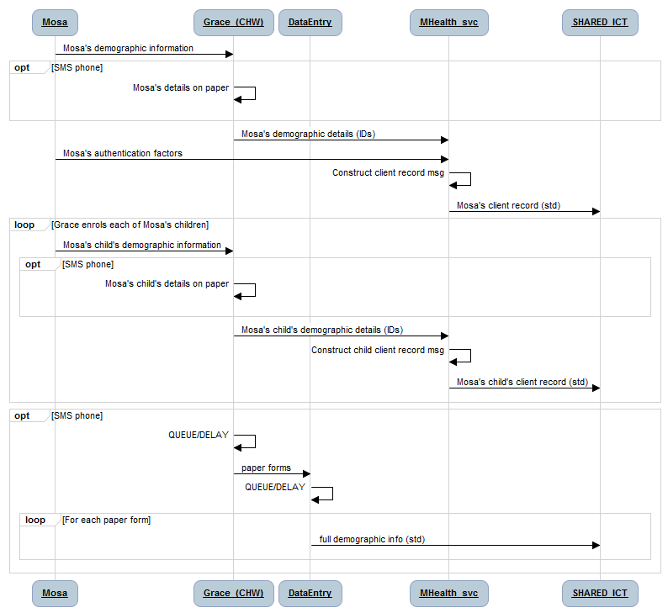

#### Discussion

This diagram illustrates the “enroll” activities described in the use case story. The characters are Mosa, the subject of care, and Grace, the community health worker (CHW). It is assumed in this interaction that Grace is using a mobile phone to effect the enrollment.

If Grace is using a basic phone, it is expected that she will only be able to communicate using text messaging (e.g. SMS) and/or interactive voice response (IVR). In this case, the data entry of large amounts of text would be a genuine challenge and very error prone. For this case, therefore, it is expected that Mosa’s detailed information will be captured on paper for data entry at a later time. Were Grace to have a feature phone with a QWERTY keyboard, such data entry could be done at the time of enrollment. Doing the data entry at the time of enrollment would reduce or eliminate the queues and delays which would characterize processing of the paper based forms.

The diagram depicts the establishing of authentication factors which may be used to authenticate Mosa. Authentication factors may be categorized as: something a person HAS, something a person KNOWS and something a person IS (biometrics). Strong authentication requires that two of these be presented (2 factor authentication or 2FA) to unambiguously establish identity. If Mosa were to have a mobile phone, even a shared phone, it could be used with a simple PIN to successfully provide 2FA. So too could an ID# (on a health card, perhaps), a photograph, or a voice print. It is recommended that Mosa’s identity be authenticated using an ID# on a card (even a preprinted card) plus at least one other factor which can be captured by the mHealth service – with a PIN the preferred option. Further, it is recommended that the mHealth service be IVR-based so literacy issues do not hamper Mosa’s ability to authenticate herself in the future.

Communication between the mobile phone and the mHealth service will depend upon the transport mode (text message, IVR, etc.) and so will vary depending on the implementation. The transport of content from the mHealth service to the Shared ICT service, however, is expected to be standards-based. The communication protocols, content and content coding would be defined in a CLIENT REGISTRY interoperability specification which is beyond the scope of this Framework.

### Sequence Diagram – Information Dissemination

#### Pseudocode

participant Mosa

participant MHealth_svc

participant SHARED_ICT

alt IF a message is generated by the service...

MHealth_svc -> MHealth_svc: generate message/recipient list

MHealth_svc -> Mosa: Send message semaphore

else IF Mosa is seeking information...

Mosa -> Mosa: Motivated to seek information

end

Mosa -> MHealth_svc: Request information

MHealth_svc -> Mosa: CALLBACK

Mosa -> MHealth_svc: Authentication tokens

MHealth_svc -> SHARED_ICT: Mosa's Authentication tokens (std)

SHARED_ICT -> SHARED_ICT authenticate Mosa

loop Navigate service menu options

alt Mosa is providing input

Mosa -> MHealth_svc: Mosa provides input

MHealth_svc -> SHARED_ICT: data exchange (std)

SHARED_ICT -> SHARED_ICT: processing

SHARED_ICT -> MHealth_svc: data exchange (std)

else The service is providing information

MHealth_svc -> Mosa: Mosa receives information

end

end

#### Diagram

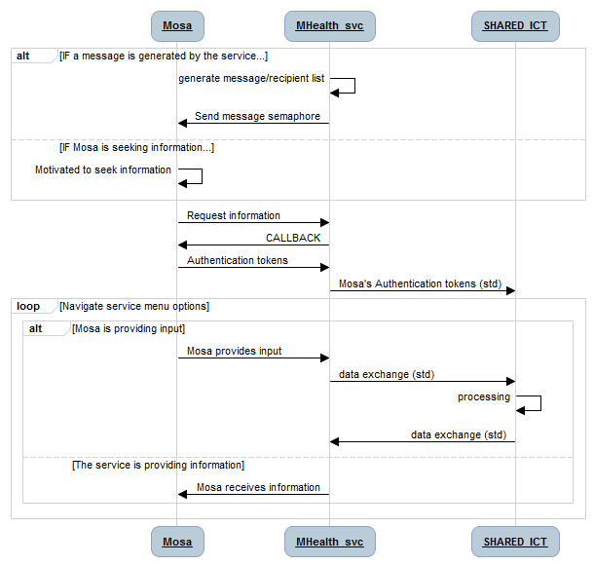

#### Discussion

The information dissemination workflow illustrates that content can either be pushed to Mosa or she can seek it. In either instance, the process for accessing content is for a CALLBACK to be made from the content service to Mosa. This is in response to her “beeping” or “flashing” the service.

Mosa uses the authentication tokens that she established during the Enrollment phase to authenticate herself to the mHealth service. Ideally, she will provide two factors of authentication (2FA). These could include:

* Initiating the request from “her” phone (or one that she shares). In this case, the phone SIM in her phone represents “something she HAS”.
* Keying in an ID# which might be her health card number (something she HAS)
* Entering a PIN (something she KNOWS)
* When prompted, speaking her name to make a voice match (something she IS).

As indicated, Mosa can be the provider of information and/or the recipient of information. It is expected that a menu based system would be hosted by the mHealth service. Ideally, this would be an interactive voice response (IVR) service that would speak instructions or questions to Mosa in her own language and prompt her to key numeric options on the keypad to navigate the menu system (e.g. “Press 1 to repeat the message. Press # to return to the main menu.”).

In addition, Mosa could be prompted to key in data which would be stored in her shared health record on the Shared ICT infrastructure such as her weight, the number of doses of medications she has left in her bottle, or a metric indicating her current sense of wellbeing (1=depressed, 33=not bad, 9=happy).

## Mosa Receives Care

### The Characters

The actors in the following scenarios are:

* Mosa (pregnant woman)
* Grace (CHW), who has a basic mobile phone
* Joshua (nurse at local Health Clinic) re: potential referral
* Samuel (the technician at the LAB)
* HOSPITAL (the nearby referral hospital)
* mHealth service with workflow capabilities
* Shared ICT service hosting shared health record information

### Act 1 – Grace and Mosa Have a Routine Care Visit

This care delivery scenario is generally based on various case studies describing Dimagi’s mHealth application: CommCare.

Grace visits Mosa in her home for a regularly scheduled visit. Grace authenticates Mosa.

Based on Mosa’s present conditions and past events, Grace follows an evidence-based care plan. Guided by the care plan, Grace obtains information and clinical observations from Mosa, which she records in Mosa’s shared health record.

Based on the observations Grace has recorded, a course of action is determined as per evidence based care guidelines.

IF Mosa’s condition warrants it, Grace refers Mosa to an appropriate care facility.

Grace prepares a paper based referral note for Mosa to take with her to the facility.

Grace logs the referral as part of Mosa’s shared health record.

Grace helps Mosa arrange transportation and accompaniment.

IF Mosa’s condition is within routine guidelines, Grace schedules a follow up visit with Mosa.

#### meHealth Implications

* There must be a mechanism for Grace to authenticate Mosa’s unique identity.
* Grace must have a way to access Mosa’s shared health record; this record must contain a log of prior events and observations and be related to a care plan. *NOTE: if Mosa’s shared health record contains information regarding her HIV status, then Grace would be directed to put Mosa on a PMTCT program and to educate her regarding birthing options which will minimize the danger of HIV transmission to Mosa’s baby.*
* There must be a mechanism for Grace to refer Mosa to a care facility.
* There must be a way to determine which facility is the appropriate one for Mosa to be referred to; there must be a register of facilities, their capabilities, and their geographic locations.
* There must be a mechanism to schedule future care events and actions.

### Act 2 – Mosa and Joshua have a Referred Care Visit

This workflow is generally based on the documented requirements of World Vision’s STEPS OVC project in Zambia.

Mosa attends the Health Clinic in the nearby village. Joshua authenticates Mosa.

Joshua retrieves Mosa’s shared health record, which indicates the reasons for the referral and provides a summary of Mosa’s current health conditions and recent observations pertinent to the referral.

Joshua follows recommended care guidelines associated with the reason for Mosa’s referral. Based on these guidelines, Joshua logs a set of clinical observations and records these in Mosa’s shared health record.

IF necessary, Joshua calls a telemedicine help desk. He uses his phone to indicate Mosa’s ID so that the help desk is able to also view Mosa’s shared health record. Joshua discusses Mosa’s care plan with help desk personnel and is able to receive clinical advice regarding what course of care is recommended.

IF warranted, Joshua takes a set of specimens from Mosa and orders a set of lab tests. The lab test order is logged in Mosa’s shared health record.

Joshua prepares the specimens and indicates that they belong to Mosa.

IF the lab test cannot be performed immediately at the Health Centre

Joshua facilitates the specimen’s transport, if necessary, to the lab.

Joshua conditionally schedules a follow up visit with Mosa, either with himself or with Grace, to review the lab results.

ELSE IF the lab test can be performed immediately, Joshua performs the test and reviews the results with Mosa

IF warranted, Joshua orders medications for Mosa and logs the order in Mosa’s shared health record.

IF the medications are available from the stores at the Health Centre, Joshua dispenses the medications to Mosa and logs the dispense transaction in Mosa’s shared health record.

ELSE IF the medications must be filled elsewhere, Joshua prepares a paper prescription for Mosa and indicates where she may have it filled.

IF Mosa’s condition warrants it, Joshua escalates Mosa’s care and refers her to an appropriate urgent or acute care facility.

Joshua prepares a paper based referral note for Mosa to take with her to the facility.

Joshua logs the referral as part of Mosa’s shared health record.

Joshua helps Mosa arrange transportation and accompaniment.

Joshua records applicable events in Mosa’s shared health record and schedules follow up, as indicated by evidence based care guidelines, with him or with Grace. Joshua discusses the care plan with Mosa and modifies it as necessary to respect her wishes.

#### meHealth Implications

* Joshua must have a way to access the care guidelines that caused Mosa to have been referred.
* Joshua must have access to a telemedicine help desk which is able to coincidentally view Mosa’s shared health record and discuss with him potential plans for Mosa’s care.
* Joshua must be able to order a lab test for Mosa and save the order to her shared health record.
* Joshua must be able to log the results of Mosa’s lab test to her shared health record, if he executes the test at the Health Centre.
* Joshua must be able to access lab results from Mosa’s shared health record once they are available there.
* If he needs to, Joshua must be able to manage the transport of Mosa’s lab specimens to an external lab.
* Joshua, or another responsible clinician, must be able to order medications for Mosa and save the order to her shared health record. There should be an alert raised if Mosa’s shared health record contains data that would cause a contraindication with the medication order.
* If Joshua is dispensing medications, he must be able to log this transaction to Mosa’s shared health record. There should be an alert raised if Mosa’s shared health record contains data that would cause a contraindication with the medications.

### Workflow Diagram (Acts 1 & 2)



Workflow Diagram: Care Delivery

The generalized care delivery diagram shown above may be described as follows:

* The process begins as a “routine care” process which may be triggered from any one of many upstream events (tick of the clock, referral, care-seeking request, etc.). It should be noted that a referral, which could imply some urgency, is initially a routine event from the point of view of the staff at the Referral Centre.
* The subject of care’s identity is authenticated. Such authentication is essential to the care delivery process. Although not included the EWEC guidelines (and therefore not addressed in this framework), such authentication processes are also essential to support financial transactions which may be associated with care events.
* Care is provided based on care guidelines (or a person-specific care plan) the execution of which is supported by local and/or shared ICT services. Information is gathered and observations logged as part of an iterative process.
* Based on the subject of care’s state of health, an intervention or escalation may be recommended by the evidence based guidelines or may be chosen by the care provider. Such escalations could include referral, the ordering of labs or medications, etc. There may be information saved to the shared health record as a result of the escalation. Such escalations may require a follow-up to be scheduled.
* If the subject’s state of health is within guidelines and no escalation is required, routine follow-up may be scheduled.

This generalized depiction of care illustrates support for the following activities from the functional profile:

* Deliver care as per care plan
* Collect and report data
* Refer clients
* Order lab tests
* Order medications

The ordering of lab tests or medications, as shown, is taken to indicate the preparing of orders for fulfillment by external entities. If the care provider is able to do lab tests (e.g. HIV test kit) or dispense medications (e.g. ORS, ART) as part of routine care delivery, then the above diagram may also be considered to illustrate:

* Review lab result
* Dispense medications.

If lab tests are ordered, specimens taken at the point of care may need to be physically transported to the external lab. Such situations will involve supply chain interactions. Likewise, dispensing medications depletes inventory which may potentially create the need for supply replenishment. Although such transactions are not included in the source EWEC workflows (and so are out of scope), transactions described in this framework would support the execution of these transactions.

### Sequence Diagram – Act 1

#### Pseudocode

participant Mosa

participant Grace_(CHW)

participant Joshua_(Clinic)

participant WorkflowEngine

participant SHARED_ICT

Grace_(CHW) -> Grace_(CHW): Grace authenticates Mosa

Grace_(CHW) -> WorkflowEngine: Mosa’s credentials

WorkflowEngine -> SHARED_ICT: Mosa’s credentials

SHARED_ICT -> SHARED_ICT: fetch Mosa’s information

SHARED_ICT -> WorkflowEngine: Mosa’s “context”

loop collect data as per guidelines

WorkflowEngine -> Grace_(CHW): get this OBS from Mosa

Grace_(CHW) -> Mosa: request OBS

Mosa -> Grace_(CHW): OBS

Grace_(CHW) -> WorkflowEngine: Mosa's OBS

WorkflowEngine -> WorkflowEngine: follow decision tree

end

WorkflowEngine -> WorkflowEngine: develop diagnosis

WorkflowEngine -> SHARED_ICT: PUT Mosa's coded OBS \n and diagnosis (std)

SHARED_ICT -> SHARED_ICT: process the PUT

alt Routine

WorkflowEngine -> Grace_(CHW): next scheduled visit in XX days

Grace_(CHW) -> Mosa: ""Mosa, I'll see you again in xx days. \nBye for now.""

else Concern

WorkflowEngine -> Grace_(CHW): recommend referral

Grace_(CHW) -> Grace_(CHW): prepare paper referral note

Grace_(CHW) -> WorkflowEngine: Mosa's referral info

Grace_(CHW) -> Mosa: ""You should go see Joshua \nat the Clinic.""

WorkflowEngine -> SHARED_ICT: PUT Mosa's referral (std)

SHARED_ICT -> SHARED_ICT: process the PUT

WorkflowEngine -> Joshua_(Clinic): Mosa's referral

end

#### Diagram



#### Discussion

The diagram indicates that Mosa is authenticated by Grace. This process may be very rudimentary (e.g. Grace may know Mosa and simply assert that Mosa is the person she is visiting using a local ID of some sort). Alternatively, there may be a process whereby Grace is invited to enter her PIN or speak her name so that she is providing her own tokens to the mHealth service at the initiation of her care visit. Either way, a context is established around Mosa’s shared health record at the onset of the visit between Mosa and Grace.

An evidence-based care guideline is followed by the mHealth service’s workflow engine. This guideline prompts Grace regarding what information she should obtain from Mosa (such as her weight, her blood pressure, etc.). Observations posted back to the mHealth service can be used to follow a “decision tree” regarding Mosa’s care plan. This care plan is posted to Mosa’s shared health record.

If it is warranted, Grace may refer Mosa to the local clinic. In this case, the referral is logged to Mosa’s shared health record and Joshua, the nurse at the clinic, is notified to expect Mosa. If Mosa’s care is routine, then her next follow-up appointment is scheduled. This may, at some future time, trigger a reminder to be sent to Mosa’s mobile phone.

### Sequence Diagram – Act 2

#### Pseudocode

participant Mosa

participant Joshua_(Clinic)

participant HOSPITAL

participant LAB

participant WorkflowEngine

participant SHARED_ICT

Mosa -> Joshua_(Clinic): ""Hello. Grace asked me to come here.""

Joshua_(Clinic) -> Mosa: ""Hello Mosa. We've been expecting you.""

Joshua_(Clinic) -> Joshua_(Clinic): Joshua authenticates Mosa's identity

Joshua_(Clinic) -> WorkflowEngine: Mosa's credentials

WorkflowEngine -> SHARED_ICT: Mosa’s credentials

SHARED_ICT -> SHARED_ICT: fetch Mosa’s information

SHARED_ICT -> WorkflowEngine: Mosa's SHR summary (std)

WorkflowEngine -> Joshua_(Clinic): Mosa's SHR summary plus \n recommended interventions

loop Joshua obtains additional information as needed

Joshua_(Clinic) -> Mosa: request additional OBS and symptoms

Mosa -> Joshua_(Clinic): OBS and symptoms

end

Joshua_(Clinic) -> WorkflowEngine: Mosa's additional symptoms and OBS

WorkflowEngine -> SHARED_ICT: Mosa's additional coded OBS \n and symptoms (std)

SHARED_ICT -> SHARED_ICT: Save Mosa’s information

opt if LAB test warranted

Joshua_(Clinic) -> WorkflowEngine: Lab order

WorkflowEngine -> SHARED_ICT: Lab order (std)

SHARED_ICT -> SHARED_ICT: save Lab Order

Mosa -> Joshua_(Clinic): specimen samples

Joshua_(Clinic) -> LAB: specimen samples; lab order

end

alt Treatable at the Clinic

Joshua_(Clinic) -> Mosa: ""Based on your health status, here is our plan of care.""

Joshua_(Clinic) -> WorkflowEngine: Mosa's plan of care

WorkflowEngine -> SHARED_ICT: Mosa's plan of care (std)

SHARED_ICT -> SHARED_ICT: Save Mosa's plan of care

Joshua_(Clinic) -> Mosa: CARE FOR MOSA

else Referral to HOSPITAL is warranted

Joshua_(Clinic) -> Mosa: ""Based on your health status, I am referring you to HOSPITAL.""

Joshua_(Clinic) -> Joshua_(Clinic): prepare paper referral note

Joshua_(Clinic) -> Mosa: ""Take this with you to the HOSPITAL.""

Joshua_(Clinic) -> WorkflowEngine: Mosa's referral info

WorkflowEngine -> SHARED_ICT: Mosa's referral (std)

SHARED_ICT -> SHARED_ICT: Save Mosa's referral

WorkflowEngine -> HOSPITAL: Mosa's referral

end

#### Diagram

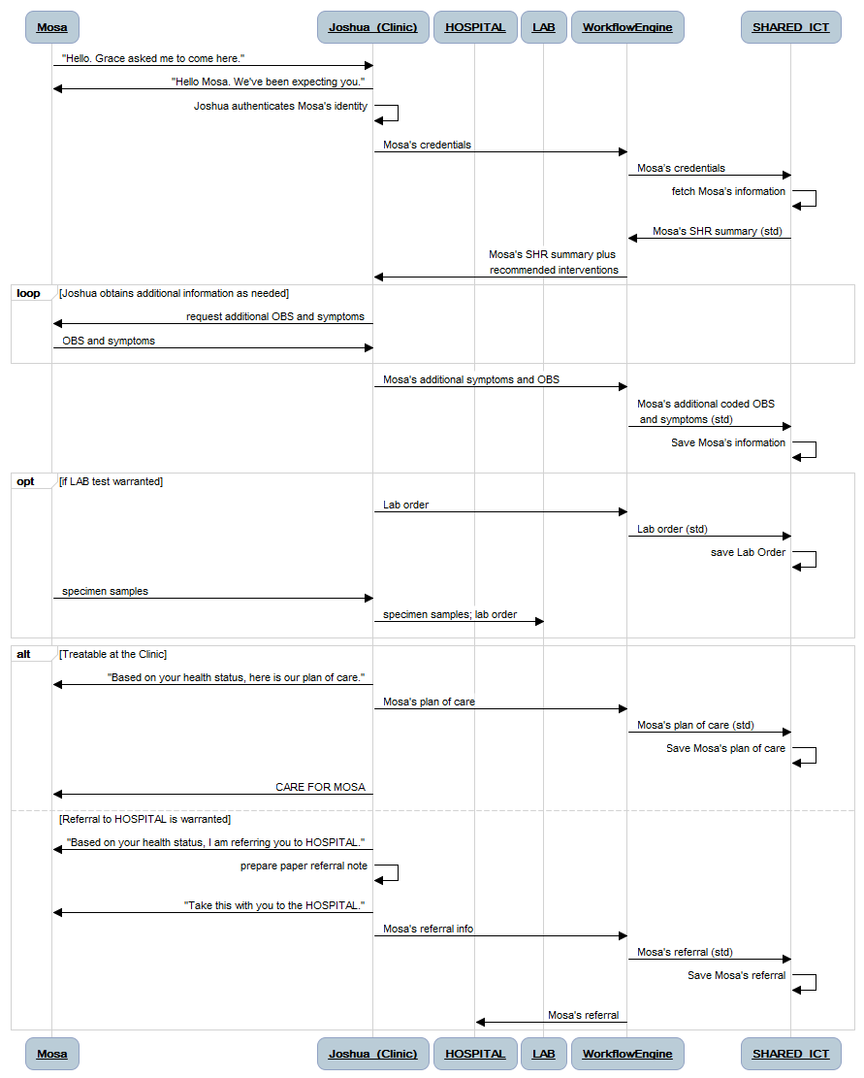

#### Discussion

The diagram indicates in its first two interactions a point that is fundamentally important to the value proposition of the *me*Health Framework: Mosa’s continuity of care is supported across care sites and over time. As was the case with Grace’s visit, Mosa’s credentials are used to set a context for her care. In this example, however, it is assumed that Joshua has a feature phone.

The implications of Joshua’s more capable mobile phone are evident in the reduced traffic with the mHealth service. Once Mosa’s information has been obtained, Joshua is able to execute workflow logic on his local mobile phone in order to navigate the guideline-based decision tree. Results and observations that he obtains regarding Mosa’s state of health may be cached and uploaded in a batch to the Shared ICT service.

It is also expected that Joshua may leverage his clinical training to alter Mosa’s plan of care, as necessary. For instance, Joshua may order lab tests and collect samples to be sent to the lab for analysis.

Whatever her plan of care, it is saved by Joshua to Mosa’s shared health record. If the plan of care includes an escalation to a referral facility, that too is saved to the Shared ICT service. As was the case when a referral was made by Grace, Joshua’s referral information will be communicated to the Hospital by the mHealth service.

## Samuel Conducts Lab Tests and Records Results

### The Characters

The actors in this scenario are:

* Mosa (pregnant woman)
* Grace (CHW), who has a basic mobile phone
* Joshua (nurse at local Health Clinic) who has a feature phone
* Samuel (the technician at the LAB) who has a computer
* mHealth service with workflow capabilities
* Shared ICT service hosting shared health record information

### The Story

This workflow is generally based on processes documented in case studies from Intel’s SMS Printer initiative and USAID’s Deliver Project report on Laboratory Standardization.

Samuel receives a set of Mosa’s blood samples which Joshua collected and a lab test order requesting the tests which should be performed on them.

Based on the paperwork and the samples he has received, Samuel confirms Mosa’s identity and opens a lab test order referencing Mosa’s client identifier and cross-referenced to Joshua’s provider identifier.

Based on a set of published guidelines for conducting the requested tests, Samuel follows a standardized procedure and logs his results into the lab test order he has opened for this test set.

Samuel saves the results to Mosa’s shared health record. Alerts are generated to let interested parties (potentially including Joshua, Grace and Mosa) know the results are available to be viewed.

#### meHealth Implications

* A supply chain must be in place that can physically deliver Mosa’s blood sample, plus the accompanying paperwork, from Joshua’s facility to Samuel’s facility.
* Samuel must have a mechanism to unambiguously identify both his direct client (Joshua) and their shared client (Mosa).
* Samuel must have access to the standardized lab protocols he will follow to execute the requested tests.
* Samuel must be able to add his test results to Mosa’s shared health record.
* A mechanism must be in place to allow interested parties to be alerted that Samuel’s test results are now available from Mosa’s shared health record.

Workflow Diagram: Support Service Delivery

An annotated version of the Care Delivery workflow diagram is shown above to illustrate how the patterns expressed in that diagram may be re-used to describe the Support Service workflow described in this Use Case Story. A discussion of the annotations follows:

* This diagram depicts a routine service delivery scenario.
* Process “A” is employed to establish the unambiguous identities of service clients. In the present example, this process would be employed to establish the enterprise provider ID and enterprise client ID of the lab test orderer and the lab test subject, respectively.
* Process “B” is employed by the lab technician to ensure standard operating procedures defined for this test are followed and that results are reported according to the established guidelines. NOTE: if warranted, the lab technician could employ the escalation pattern to accommodate situations where the test could not be completed as per guidelines and the work must be referred to another facility.
* Process “C” is employed to allow follow-up of the test results to be done by interested parties (such as the provider, the subject of care, or the associated community health worker).

Workflow Diagram: Service Alerts

An annotated version of the Information Dissemination workflow diagram is shown above to illustrate how the patterns expressed in that diagram may be employed to facilitate the “Schedule Follow-up” process described above. A discussion of the annotations follows:

* The diagram depicts a routine information delivery scenario.
* As indicated in Process “A”, the posting of lab results to a shared health record may be treated by the Shared ICT infrastructure as a trigger event. The firing of the trigger may invoke logic that causes one or more alerts to be posted to a set of recipients manually indicated in the lab result or predefined as part of a business rule (e.g. alert the ordering provider, the client, and the client’s identified community care provider).
* Recipients of the system-generated alerts are able to follow the typical workflow for Information Dissemination.

### Sequence Diagram

#### Pseudocode

participant Mosa

participant Grace_(CHW)

participant Joshua_(Clinic)

participant LAB

participant WorkflowEngine

participant SHARED_ICT

Joshua_(Clinic) -> LAB: specimens & lab order

LAB -> SHARED_ICT: establish context (std)

SHARED_ICT -> LAB: contextual info (std)

LAB -> LAB: perform lab test per guidelines

LAB -> SHARED_ICT: lab results (std)

SHARED_ICT -> WorkflowEngine: lab result notification (std)

WorkflowEngine -> Joshua_(Clinic): lab result notification

Joshua_(Clinic) -> WorkflowEngine: request lab results

WorkflowEngine -> SHARED_ICT: request lab results (std)

SHARED_ICT -> SHARED_ICT: fetch lab results

SHARED_ICT -> WorkflowEngine: lab results (std)

WorkflowEngine -> Joshua_(Clinic): lab results

Joshua_(Clinic) -> WorkflowEngine: follow-up plan

WorkflowEngine -> SHARED_ICT: follow-up plan (std)

SHARED_ICT -> SHARED_ICT: save follow-up plan

alt Mosa follow-up with Joshua

WorkflowEngine -> Mosa: schedule visit with Joshua

else Mosa follow-up with Grace

WorkflowEngine -> Grace_(CHW): schedule visit with Mosa

WorkflowEngine -> Mosa: schedule visit with Grace

end

#### Diagram

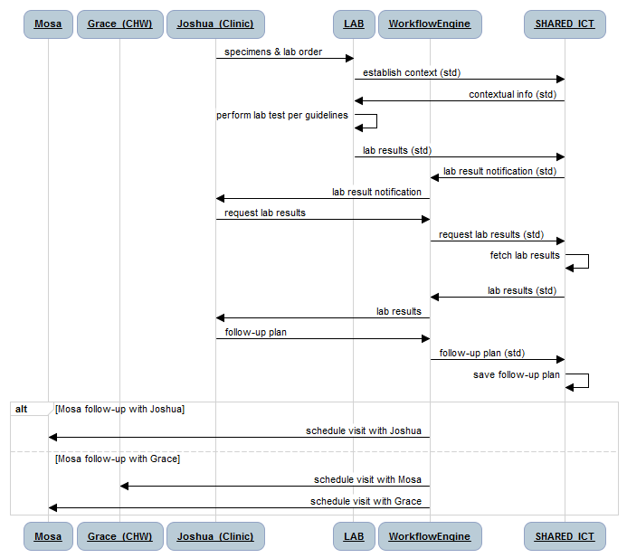

#### Discussion

The diagram illustrates that the receipt of physical specimens plus the accompanying lab order is the trigger event for Samuel (the lab technician at LAB) to begin his work. The accompanying paperwork would indicate Mosa’s ID (perhaps her client ID# from her health card), and Joshua’s ID (perhaps from his provider ID card), and the lab tests which are to be performed (using a code system). Samuel would use this information to establish a context for his tests by posting a message to the Shared ICT service. The message would provide guidelines regarding the test plus any particular information which Joshua may have entered in the lab order.

Samuel would execute the lab test as per the guidelines for performing such tests. He would post the results up to the Shared ICT, where they would be stored as part of Mosa’s shared health record.

The storing of the lab tests is a trigger event for the mHealth service’s workflow engine. The Shared ICT service invokes the mHealth service to alert Joshua that Mosa’s lab results are available. Joshua retrieves the lab results and establishes a follow-up plan accordingly, which is saved to Mosa’s shared health record.

Based on Joshua’s follow-up plan, an alert may be sent to Mosa for her to attend a visit with Joshua to review her lab results and establish a new care plan based on the findings. Alternatively, Joshua may recommend that Mosa and Grace should meet to review the results and that Grace will discuss with Mosa the results and their implications.

## Grace Provides Mosa with Medications

### The Characters

The actors in the following scenarios are:

* Mosa (pregnant woman)
* Grace (CHW), who has a basic mobile phone
* Joshua (nurse at local Health Clinic) re: potential referral
* mHealth service with workflow capabilities
* Shared ICT service hosting shared health record information

### The Story

Mosa has been placed on a PMTCT protocol by Joshua.

Grace visits Mosa to conduct a regular follow-up antenatal care visit. Mosa is on a care program reflective of the fact that she is HIV positive.

As part of the visit, Grace provides Mosa with her next course of medications as per the PMTCT guidelines. The dispense transaction is logged to Mosa’s shared health record.

After the visit with Mosa, Grace goes to the clinic to replenish her stock of medications. The transfer of the medications from the medications store at Joshua’s clinic to Grace’s CHW kit bag is logged to the Shared ICT service.

### Workflow

The workflow is the same as was illustrated for Mosa’s Care Delivery use case story. Because she has been placed on the PMTCT protocol, it is now part of Mosa’s “routine care” to receive the medications.

### Sequence Diagram

#### Pseudocode

participant Mosa

participant Grace_(CHW)

participant Joshua_(Clinic)

participant WorkflowEngine

participant SHARED_ICT

note over Mosa, Joshua_(Clinic): Mosa is on a PMTCT protocol

note over Mosa, Grace_(CHW): Grace and Mosa have routine visit

WorkflowEngine -> Grace_(CHW): replenish Mosa's medications

Grace_(CHW) -> Mosa: dispense medications

Grace_(CHW) -> WorkflowEngine: medications dispensed

WorkflowEngine -> SHARED_ICT: medications dispensed (std)

SHARED_ICT -> SHARED_ICT: save dispense transaction

note over Mosa, Grace_(CHW): Grace and Mosa conclude visit

note over Grace_(CHW), Joshua_(Clinic): Grace goes to clinic to replenish stock

Joshua_(Clinic) -> WorkflowEngine: reconcile Grace's inventory

WorkflowEngine -> SHARED_ICT: reconcile inventory (std)

SHARED_ICT -> SHARED_ICT: lookup inventory

SHARED_ICT -> WorkflowEngine: inventory balance (std)

WorkflowEngine -> Joshua_(Clinic): inventory balance

alt discrepencies

Joshua_(Clinic) -> Grace_(CHW): resolve discrepencies

else ok

Joshua_(Clinic) -> Grace_(CHW): replenish meds stock

Joshua_(Clinic) -> WorkflowEngine: meds stock transfer

WorkflowEngine -> SHARED_ICT: meds stock transfer (std)

SHARED_ICT -> SHARED_ICT: log meds stock transfer

end

#### Diagram

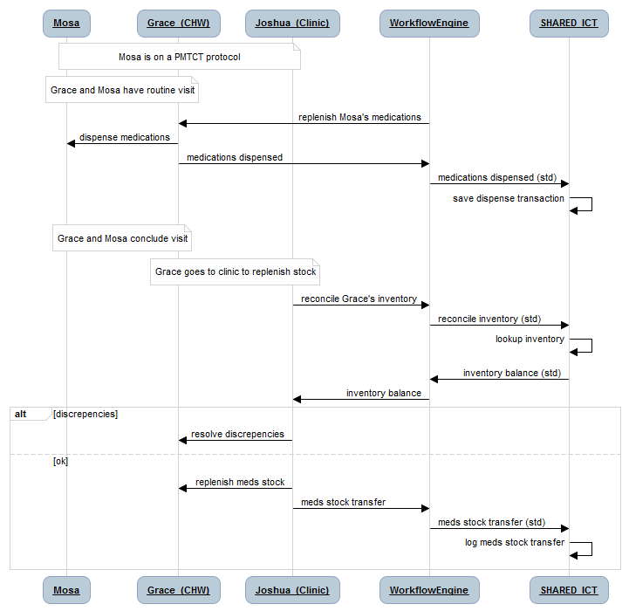

#### Discussion

The diagram illustrates an important aspect of the *me*Health Framework: care delivery transactions may richly express parallel transactions such as reportable indicators and, in this case, supply chain transactions. Based on the fact that Mosa is on a PMTCT protocol, the mHealth service’s workflow engine has instructed Grace to dispense medications to Mosa. The act of Grace doing this, and logging the transaction to the mHealth services has accomplished two things:

1. Mosa’s shared health record has a log of the medications she has been given
2. A depletion is recorded against the inventory record in the Shared ICT service that reflects the supply of medications in Grace’s CHW “kit bag”.

When Grace goes to the clinic to replenish her stock of medications, an inventory reconciliation can be done by Joshua. If there are discrepancies, Joshua and Grace can address them. When Joshua transfers medications from his clinic stores to Grace’s kit bag, the transaction is logged to the mHealth service. This in turn updates the Shared ICT service which now has new inventory balances for Joshua’s stores and Grace’s kit bag. Such transactions are invaluable in supporting supply chain management of medications.

## Administrative Use Cases

The examples so far have described care delivery or service delivery use case stories. A number of administrative and health system management use cases are also important to the operation of the enterprise and the fleshing out of the enterprise viewpoint. These are described (at a top level only) in the following section.

### The Characters

* Grace (CHW)
* Sarah (Grace’s CHW Manager)
* Joshua (nurse at the clinic)

### Sarah Enrolls Grace as a CHW

Sarah (CHW manager) provides skills training for Grace

Grace successfully completes an “exam” (or provides some other evidence of her skills) and is registered by Sarah as a CHW

Grace’s ID information is uploaded to the Shared ICT service, including the “credentials” needed to authenticate her (e.g. a PIN, or her voice print, or a CHW ID card #)

### Sarah Reviews CHW Performance

On a regular basis, Sarah is able to review the degree of CHW adherence to the care guidelines and community care delivery goals that have been established.

Results are reported for the entirety of Sarah’s team of CHWs and by individual CHW

Based on the metrics, Sarah is able to provide management guidance at the program level (for the entire team) or on an individual basis.

Based on her team’s performance, Sarah’s manager is able to review Sarah’s performance, too.

### Joshua Records Vital Statistics

Joshua attends at the delivery of Mosa’s baby.

Joshua records pertinent details regarding Mosa’s health during and immediately following delivery. The details become part of Mosa’s shared health record.

Joshua records pertinent details (sex, general health, etc.) regarding Mosa’s baby and establishes a new shared health record for the infant. The information is logged by the Shared ICT service as a “birth event” and automatically updates the national vital statistics database regarding births and deaths.

# Information Model

## Overview

Detailed discussion regarding the information model to support the described workflows is explored in the following sections. It is strongly recommended that an overall, coherent information model should be embraced which adheres to an internationally balloted standard. There are two such comprehensive standards to choose from: the HL7v3 RIM and the OpenEHR RM.

## Subject of Care

It is recommended that the information model for subjects of care should generally be based upon ISO 22220 Health Informatics – Identification of subjects of health care and on the HISA model for same. An information model informed by these two international standards may be characterized as follows:

* Enterprise Client ID (ECID)
* Name
* Additional demographic data (e.g. birth date, sex, mother’s original family name, etc.)
* Address
* Electronic communication (e.g. phone #, email address, etc.)
* Biometric identifier (e.g. photograph, voice print, etc.)

In the ISO 22220 standard, only the first two of these data elements are flagged as mandatory. The ISO 22220 standard also provides significant detail regarding the underlying structure of each of these top level data elements; such detail is beyond the scope of this framework.

The HISA standard (ISO 12967 part 2, IV) describes an association between the subject of care class and various other classes described in the top level class diagram. These include:

* Contacts: there may be 0..* healthcare system contacts associated with the ECID
* PeriodOfCare: there may be 0..* periods of care related to the ECID
* ClinicalInformation: there may be 0..* clinical documents or messages associated with the ECID
* Agent: there may be 0..* individuals and/or organizations that take care of the referenced ECID

Details regarding these associations are described in detail in ISO 12967-2 and are beyond the scope of this framework.

Both the HL7v3 RIM and the OpenEHR RM are consistent with the aforementioned guidance.

## Provider of Care

It is recommended that the information model for providers of care should generally be based upon ISO 27527 Health Informatics – Provider identification and on the HISA model for same. An information model informed by these two international standards may be characterized as follows:

* Enterprise Provider ID (EPID)
* Individual Provider data
  + Individual Provider Name
  + Individual Provider demographic details
  + Individual Provider Field of practice
  + Address
  + Electronic communication (e.g. phone #, email address, etc.)
  + Individual Provider Biometric identifier (e.g. photograph, voice print, etc.)
* Provider Organization data
  + Organization ID (ELID)
  + Organization start date
  + Organization end date
  + Organization name details
  + Organization site details

The ISO 27527 standard provides significant detail regarding the underlying structure of each of these top level data elements; such detail is beyond the scope of this framework.

The HISA standard (ISO 12967 part 2, IV) describes an association between the agent class (a generalization of providers of care) and various other classes described in the top level class diagram. These include:

* Agent: there may be 0..* other agents related to or associated with the EPID; this is reflective of the fact that care delivery organizations are also specializations of the agent class and that there may be multiple providers on a care team
* Contacts: there may be 0..* healthcare system contacts associated with the EPID
* Activity: there may be 0..* activities in which this EPID is a participant
* ClinicalInformation: there may be 0..* clinical documents or messages associated with the EPID

Details regarding these associations are described in detail in ISO 12967-2 and are beyond the scope of this framework.

Both the HL7v3 RIM and the OpenEHR RM are consistent with the aforementioned guidance.

## Facility/Location

It is recommended that the information model for facilities/locations be generally based on the description of organizations that appears in ISO 27527, on the HL7 location of care message model and on the HISA class model for resources. An information model informed by these sources may be characterized as follows:

* Enterprise Location ID (ELID)
* Name
* Address
* Type (e.g. hospital, lab, etc.)
* Site status (e.g. active at date, decommissioned at date, etc.)
* Organization or Jurisdiction (e.g. health district)
* Available Services (e.g. surgical services, diagnostic imaging, etc.)
* Contact details (e.g. contact party, phone #, email address, etc.)

Details regarding the structure and code sets for these data elements may be found in the HL7 standards and the ISO 27527 standard and are beyond the scope of this framework.

## Care Guideline/Plan

This is perhaps the most glaring area where standards are required. The meHealth Framework relies on the systematic adherence to evidence based care guidelines. It is essential that there be a clear and unambiguous mechanism for describing these guidelines.

It is recommended that care plans be expressed using the Arden Syntax. Arden is a mature ANSI/HL7 standard originally standardized by ASTM in 1992 and currently in revision 2.7 (2008). It is used to develop Medical Logic Modules (MLM), which may be called using a remote procedure call pattern and used to drive decision support. Arden syntax is broadly embraced, is supported by commercial vendors and open source implementations (e.g. <http://arden2bytecode.sourceforge.net/>), and is used in practice by leading institutions. Arden MLMs are use by the Regenstreif Institute in its CARE system to deliver reminders or hints to clinicians regarding patient treatment recommendations.

A clinical guideline expressed using Arden Syntax requires an unambiguous information model of a subject of care’s current health state. The information model for such a model is described in the following section.

The HL7 wiki site for Arden includes a full description of the language and its use. It may be found here: <http://wiki.hl7.org/index.php?title=Product_Arden>. A library of clinical care guidelines is available at [www.guideline.gov](http://www.guideline.gov). The complete WHO Every Woman Every Child detailed package of interventions is available here: <http://www.who.int/making_pregnancy_safer/documents/924159084x/en/index.html>. The WHO standard clinical guidelines for MNCH care are available here: <http://whqlibdoc.who.int/hq/2007/a91272.pdf>.

## Care Coordination Document

Guideline-based continuity of care requires there be an unambiguous way to describe a subject of care’s current health condition. The information model for such a description would need to be able to include the various elements of a subject’s current condition including:

* Reasons for Care
* Histories
* Medications
* Physical exams
* Relevant studies
* Plans of care
* Procedures performed
* Clinical assessments

The recommendation to employ the CDA information model is related to, and complementary to, the results of a study funded by USAID/PEPFAR which developed engineering and technology specifications based on the meHealth Framework.

It is recommended that the information model for the *me*Health Framework should generally follow the HL7 Clinical Document Architecture (CDA v2) model as constrained by the Integrating the Healthcare Enterprise (IHE) Patient Care Coordination (PCC) profiles. The full description of this information model, including the templates which may be used to constrain the model, may be found at the IHE PCC wiki, here: <http://wiki.ihe.net/index.php?title=CDA_Release_2.0_Content_Modules>.

CDA documents are very flexible regarding both their content and the messaging protocols which may be used to exchange them. A CDA document may contain information expressed using either HL7v3 or HL7v2 data models, or openEHR archetypes. The CDA supports clinical expression across multiple maturity levels:

* Level 1 – structured header information plus unstructured content in a MIME format (the binary format commonly used to contain email attachments) which could simply be a scanned image of a document or a PDF. A level 1 CDA supports “eyeball to eyeball” interoperability; knowledgeable clinicians can use level 1 CDAs to get on the “same page” regarding a patient’s condition.
* Level 2 – structured header plus structured section headings in the body of the document, which may contain unstructured data, plus a BLOB. Level 2 CDA are able to support electronic categorization of human-readable content (because of the structured headings).
* Level 3 – structured header, plus structured headings in the body, each heading containing structured and coded content. A level 3 CDA supports semantic interoperability and could support automated decision support.

A CDA document may be conveyed using HL7v3 messaging, HL7v2 messaging, or using IHE cross document exchange (XDS) profiles. CDA document profiles may be developed or existing profiles may be constrained using the open source Model-driven Healthcare Tools (MDHT) available from the Open Health Tools ([www.openhealthtools.org](http://www.openhealthtools.org)) forge.

# Operationalizing the Framework

## The Collaborative Health Platform

Meetings were convened at the Greentree Centre in New York City in May 2011 to discuss the development of a collaborative platform for donor-funded mHealth and eHealth projects. Attendees embraced the idea of a virtuous circle as illustrated by the graphic shown below.



CHP Virtuous Circle

This diagram indicates the following:

* The mHealth Alliance will play a central, facilitating role; it will (quite literally) provide the HUB for the virtuous circle.
* The healthunbound.org (HUB) website will be leveraged as a place to curate “the commons”; IP and engineering assets that will support mHealth and eHealth strategy, technology and product development on behalf of all stakeholders. HUB will facilitate discussion and consensus-building around these common assets and specifications.
* Architectural and engineering assets stored on the HUB can be prototyped and experimented with in Labs who are participating as global *me*Health collaborators. Such labs can include the HEAL (South Africa), Mohawk College (Canada) and others. The work product of these labs will include proof-of-concept reference implementations and software tooling which may be leveraged by developers who are consuming or extending the functionality of the commons.
* Successful prototypes can be migrated from the Lab to hosted production environments. It is expected that private-public partnerships will be forged so common *me*Health infrastructure may be made available to multiple donor-funded and implementation-partner led projects. These enterprise-class deployments will support continuity of care between multiple stakeholders collaborating using standards-based interoperability profiles.
* Projects will leverage the shared infrastructure to support continuity of care within the jurisdictions where they operate. Lessons from projects implementations and operations will be fed back to the HUB and inform the next iteration of IP and specifications curated there.

## Technical Artefacts

A growing body of IP is available on HUB to help facilitate the development of interoperability specifications and companion engineering diagrams. These include:

* This document (describing the meHealth Framework for MNCH).
* Links, background documents and journal articles which informed the architectural approach favoured by the meHealth Framework.
* Engineering and Technology specifications, developed under a NetHope-led project funded by USAID/PEPFAR which extend the enterprise architecture described by the meHealth Framework.
* Overview presentations (in PowerPoint format) that describe the meHealth Framework plus prototyping efforts that have already been undertaken to help inform ongoing standards-based specification development.
* Links to open source software and tooling that may be employed to realize the designs express in the NetHope project documents.

## Continuous Improvement and Evolution

As part of its strategic plan, the mHealth Alliance is convening two working groups to explore specific issues around Evaluation of mHealth (and eHealth) interventions and to develop common standards and specifications which may be embraced by stakeholders to address the current challenges regarding technology proliferation and lack of interoperability. This present document is intended to:

1. Evolve based on input from the community to better address the issues described above and to reflect the collective experience of field-based implementations.
2. Support, in its information models and its data message specifications, the requirements identified by the Evaluation working group.

It is expected, therefore, that this document will be maintained as a living document and will improve with each iteration based on the input from interested stakeholders.

# References

1. WHO-HMN. *Guidance for the Health Information Systems (HIS) Strategic Planning Process*. Geneva, Switzerland: World Health Organization; 2009:144.

2. WHO-HMN. *Assessing the National Health Information System: An Assessment Tool*. Version 4. Geneva, Switzerland: World Health Organization; 2008.

3. WHO-HMN. *Framework and Standards for Country Health Information Systems*. 2nd ed. Geneva, Switzerland: World Health Organization; 2008:72. Available at: http://www.who.int/healthmetrics/documents/hmn_framework200803.pdf.

4. Bhutta Z a, Ali S, Cousens S, et al. Alma-Ata: Rebirth and Revision 6 Interventions to address maternal, newborn, and child survival: what difference can integrated primary health care strategies make? *Lancet*. 2008;372(9642):972-89. Available at: http://www.ncbi.nlm.nih.gov/pubmed/18790320.

5. Freedman L, Waldman R, Pinho H de, et al. *Who’s got the power? Transforming health systems for women and children. Summary version of the Task Force on Child Health and Maternal Health.* New York; 2005.

6. Lewin S, Lavis JN, Oxman AD, et al. Supporting the delivery of cost-effective interventions in primary health-care systems in low-income and middle-income countries: an overview of systematic reviews. *Lancet*. 2008;372(9642):928-39. Available at: http://www.ncbi.nlm.nih.gov/pubmed/18790316.

7. Campbell OMR, Graham WJ. Strategies for reducing maternal mortality: getting on with what works. *Lancet*. 2006;368(9543):1284-99. Available at: http://www.ncbi.nlm.nih.gov/pubmed/17027735 [Accessed June 12, 2011].

8. Kerber KJ, Graft-Johnson JE de, Bhutta Z a, et al. Continuum of care for maternal, newborn, and child health: from slogan to service delivery. *Lancet*. 2007;370(9595):1358-69. Available at: http://www.ncbi.nlm.nih.gov/pubmed/17933651.

9. Kupersmith J, Francis J, Kerr E, et al. Advancing evidence-based care for diabetes: lessons from the Veterans Health Administration. *Health affairs (Project Hope)*. 2007;26(2):w156-68. Available at: http://www.ncbi.nlm.nih.gov/pubmed/17259199 [Accessed November 14, 2010].

10. Perlin JB, Kolodner RM, Roswell RH. The Veterans Health Administration: quality, value, accountability, and information as transforming strategies for patient-centered care. *HealthcarePapers*. 2005;5(4):10-24. Available at: http://www.ncbi.nlm.nih.gov/pubmed/16088305.

11. WHO. *Primary health care: now more than ever*. Geneva, Switzerland: World Health Organization; 2008:119.

12. Maeseneer J De, Weel C van, Egilman D, et al. Funding for primary health care in developing countries. *BMJ (Clinical research ed.)*. 2008;336(7643):518-9. Available at: http://www.pubmedcentral.nih.gov/articlerender.fcgi?artid=2265338&tool=pmcentrez&rendertype=abstract [Accessed April 3, 2011].

13. JCIE. *Global Action for Health System Strengthening Policy Recommendations to the G8*. Tokyo, Japan; 2009:1-131. Available at: http://www.jcie.org/researchpdfs/takemi/full.pdf.

14. Jamison D, Breman J, Measham A, et al. eds. *Priorities in Health*. 2nd ed. Washington, DC: The World Bank; 2006:236. Available at: http://files.dcp2.org/pdf/PIH/PIH.pdf.

15. Jamison D, Breman J, Measham A, et al. eds. *Disease Control Priorities in Developing Countries, Second Edition*. Second. Washington, DC: The World Bank; 2006:1352.

16. Lewin S, Munabi-Babigumira S, Glenton C, et al. Lay health workers in primary and community health care for maternal and child health and the management of infectious diseases. *Cochrane Database of Systematic Reviews*. 2010;28(3):206. Available at: http://www.ncbi.nlm.nih.gov/pubmed/21535109.

17. Svoronos T, Mjungu D, Dhadialla P, Luk R, Zue C. CommCare : Automated Quality Improvement To Strengthen Community-Based Health The Need for Quality Improvement for CHWs. In: *Medinfo 2010*. Cape Town: International Medical Informatics Association; 2010.

18. Lehmann U, Sanders D. *Community health workers: What do we know about them? The state of the evidence on programmes, activities, costs and impact on health outcomes of using community health workers*. Geneva, Switzerland; 2007:34.

19. WHO. *Every Woman Every Child -- Packages of Interventions for Family Planning, Safe Abortion Care, Maternal, Newborn and Child Health*. Geneva, Switzerland; 2010:21.

20. OECD. *The Paris declaration on aid effectiveness and the Accra Agenda for action*. Paris / Accra Available at: http://scholar.google.com/scholar?hl=en&btnG=Search&q=intitle:The+Paris+Declaration+on+Aid+Effectiveness+and+the+Accra+Agenda+for+Action#4 [Accessed December 3, 2011].

21. Sepúlveda J, Bustreo F, Tapia R, et al. Improvement of child survival in Mexico: the diagonal approach. *The Lancet*. 2006;368(9551):2017-2027. Available at: http://linkinghub.elsevier.com/retrieve/pii/S014067360669569X [Accessed August 19, 2010].

22. WHO. *Keeping promises, measuring results (Advance Copy)*. Geneva, Switzerland; 2011:26.

23. Evaluation AN, World OF, Group B, Information IN, Technologies C. *AN EVALUATION OF WORLD BANK GROUP ACTIVITIES Capturing Technology for Development*.

24. Evans D, Elovainio R, Humphreys G. *HEALTH SYSTEMS FINANCING The path to universal coverage*. Geneva, Switzerland: WHO; 2010:106.

25. Rannan-Eliya R. *Strengthening health financing in partner developing countries*. 2009:30.

26. Vital Wave Consulting. *mHealth for Development*. Washington, DC; 2009. Available at: http://www.vitalwaveconsulting.com/pdf/mHealth.pdf.

27. Anon. NIH Enterprise Architecture. 2011. Available at: http://enterprisearchitecture.nih.gov/About/What/ [Accessed June 5, 2011].