Integrating the Healthcare Enterprise

IHE Quality, Research and Public Health
Technical Framework Supplement

Mobile Aggregate Data Exchange
(mADX)

HL7® FHIR® Release 4
Using FHIR Resources at FMM Level 2

Rev. 1.0 – Draft for Public Comment

Date: June 17, 2019
Author: QRPH Technical Committee
Email: qrph@ihe.net

Please verify you have the most recent version of this document. See here for Trial Implementation and Final Text versions and here for Public Comment versions.
Foreword
This is a supplement to the IHE Quality, Research and Public Health (QRPH) Technical Framework. Each supplement undergoes a process of public comment and trial implementation before being incorporated into the volumes of the Technical Frameworks.
This supplement is published on June 17, 2019 for Public Comment. Comments are invited and can be submitted at https://www.ihe.net/QRPH_Public_Comments. In order to be considered in development of the Trial Implementation version of the supplement, comments must be received by July 17, 2019.
“Boxed” instructions like the sample below indicate to the Volume Editor how to integrate the relevant section(s) into the relevant Technical Framework volume.
Amend Section X.X by the following:
Where the amendment adds text, make the added text bold underline. Where the amendment removes text, make the removed text bold strikethrough. When entire new sections are added, introduce with editor’s instructions to “add new text” or similar, which for readability are not bolded or underlined.

General information about IHE can be found at www.ihe.net.
Information about the IHE QRPH domain can be found at http://www.ihe.net/IHE_Domains.
Information about the organization of IHE Technical Frameworks and Supplements and the process used to create them can be found at http://www.ihe.net/IHE_Process and http://www.ihe.net/Profiles.
The current version of the IHE QRPH Technical Framework can be found at http://www.ihe.net/Technical_Frameworks.

CONTENTS

Introduction to this Supplement 5
Open Issues and Questions 6
Closed Issues 7
General Introduction 8
Appendix A – Actor Summary Definitions 8
Appendix B – Transaction Summary Definitions 8
Appendix D – Glossary 8
Volume 1 – Profiles 9
Copyright Licenses 9
Domain-specific additions 9
X Mobile Aggregate Data Exchange (mADX) Profile 10
X.1 mADX Actors, Transactions, and Content Modules 10
X.1.1 Actor Descriptions and Actor Profile Requirements 12
X.1.1.1 Content Data Structure Creator 12
X.1.1.2 Content Data Structure Consumer 12
X.1.1.3 Content Creator 12
X.1.1.4 Content Consumer 13
X.1.1.5 Care Services Update Supplier 13
X.1.1.6 Care Services Update Consumer 13
X.2 mADX Actor Options 13
X.2.1 Validate mADX Option 13
X.3 mADX Required Actor Groupings 14
X.4 mADX Overview 14
X.4.1 Concepts 15
X.4.2 Use Cases 15
X.5 mADX Security Considerations 15
X.6 mADX Cross Profile Considerations 16
X.6.1 Aggregate Data Exchange (ADX) 16
X.6.1.1 The Mobile Care Services Discovery (mCSD) 16
Appendices 17
Volume 2 – Transactions 18
3.58 Send Indicator Report [QRPH-58] 18
3.58.1 Scope 18
3.58.2 Actor Roles 18
3.58.3 Referenced Standards 19
3.58.4 Messages 19
3.58.4.1 Send Indicator Report 19
3.58.4.1.1 Trigger Events 19
3.58.4.1.2 Message Semantics 19
3.58.4.1.3 Expected Actions 20
3.58.4.2 Send Indicator Report Result 20
3.58.4.2.1 Trigger Events 20
3.58.4.2.2 Message Semantics 21
3.58.4.2.3 Expected Actions 21
3.Y.5 Protocol Requirements 22
3.58.6 Security Considerations 22
3.58.6.1 Security Audit Considerations 22
3.Y.6.1.(z) <Actor> Specific Security Considerations 22
3.59 Retrieve Indicator Definition [QRPH-59] 22
3.59.1 Scope 23
3.59.2 Actor Roles 23
3.59.3 Referenced Standards 23
3.59.4 Messages 24
3.59.4.1 Retrieve Data Structure Definition 24
3.59.4.1.1 Trigger Events 24
3.59.4.1.2 Message Semantics 25
3.59.4.1.3 Expected Actions 25
3.59.4.2 Data Structure Definition Response 25
3.59.4.2.1 Trigger Events 25
3.59.4.2.2 Message Semantics 25
3.59.5.2.3 Expected Actions 27
Appendices 28
Volume 2 Namespace Additions 28
Volume 3 – Content Modules 29
5 IHE Namespaces, Concept Domains and Vocabularies 30
5.1 IHE Namespaces 30
5.2 IHE Concept Domains 30
6 Content Modules 32
7 DICOM® Content Definitions 32
8 mADX Content Modules 33
8.1 Overview of mADX process 33
8.2 Data Structure Definition (DSD) 33
8.3 mADX Message Exchange Constraints (Informative) 33
Appendices to Section 8 35
Appendix 8A – FHIR Profile on Terminologies 36
Appendix 8B – (Informative) Sample mADX DSD 37
Appendix 8C – (Informative) Sample mADX message 47
Appendix 8D – (Informative) Formatting of times and time intervals in mADX 52
Appendix X – (Informative) Sample Indicator definition CQL file 54
Volume 4 – National Extensions 65

Introduction to this Supplement

Whenever possible, IHE profiles are based on established and stable underlying standards. However, if an IHE domain determines that an emerging standard has high likelihood of industry adoption, and the standard offers significant benefits for the use cases it is attempting to address, the domain may develop IHE profiles based on such a standard. During Trial Implementation, the IHE domain will update and republish the IHE profile as the underlying standard evolves.
Product implementations and site deployments may need to be updated in order for them to remain interoperable and conformant with an updated IHE profile.
This mADX Profile is based on Release 4 of the emerging HL7® FHIR® specification. HL7 describes FHIR Change Management and Versioning at https://www.hl7.org/fhir/versions.html.
HL7 provides a rating of the maturity of FHIR content based on the FHIR Maturity Model (FMM): level 0 (draft) through N (Normative). See http://hl7.org/fhir/versions.html#maturity.
The FMM levels for FHIR content used in this profile are:

FHIR Content  (Resources, ValueSets, etc. | FMM Level
Measure | 2
MeasureReport | 2

The Mobile Aggregate Data Exchange (mADX) Profile supports interoperable public health reporting of aggregate health data. These most typically take the form of routine reports (weekly, monthly, quarterly etc.) from a health facility to some administrative jurisdiction such as a health district, though there are numerous other use cases such as international reporting and community health worker reporting.
As the motivating context and use cases for this profile are the same as the Aggregate Data Exchange (ADX) Profile, they are not repeated here. The mADX and ADX file are intended to be functionally equivalent.
Difference from existing ADX Profile
The primary purpose of the mADX Profile is to provide an alternative for the exchange and management of the metadata required for routine reporting by replacing the use of SDMX with HL7 FHIR. Metadata data in ADX, or ADX/DSD, is a profile of the SDMX Data Structure Definition (DSD). Challenges in working with it include:
- Scaling limitations as it requires ongoing maintenance of facility and location lists in the ADX/DSD.
- Bandwidth limitations when trying to transfer an ADX/DSD for validation of an ADX. Facility and location lists can be large which complicates deployments in resource constrained settings.
- Management and exchange of code lists for disaggregators.
mADX profiles HL7 FHIR Terminology Services and the HL7 FHIR Measure resource to produce a mADX/DSD. Additionally this profile makes use of the Mobile Care Services Discovery (mCSD) Profile for facility and location data. The mADX Profile will allow vendors and implementers to utilize the robust ecosystem of tools around HL7 FHIR and promote standards-based routine reporting.
Approach
This specification profiles HL7 FHIR to define a mADX/Data Structure Definition (DSD) to normatively describe the structure of routine aggregate data reports as a mADX message. The mADX Profile uses the following actors:
- the Content Creators and the Content Consumer for the creation and consumption of mADX/DSD messages
- the Content Data Structure Creator and the Content Data Structure Consumer, defined in the ADX Profile, which produce and consume the mADX/DSD respectively
- the Care Services Update Supplier and the Care Services Update Consumer, defined in the mCSD Profile, for supplying and consuming location data.
The mADX/DSD is used to define the metadata required to validate a mADX message and defined in terms of a HL7 FHIR Terminology Service and a FHIR Measure resource. The HL7 FHIR Terminology Services are used for the exchange of disaggregators and IHE’s Mobile Care Services Discovery (mCSD) is used for the exchange of location metadata. These services may be used by the Content Creator and the Content Consumer to validate the structural metadata of mADX data messages exchanged.

Open Issues and Questions
- Are the current validation options sufficient, currently it is only the Content Consumer. Potential to validate on submission of data to the Content Consumer (in which case the Validate Option is only for the Content Consumer and not so much the Content Creator) or as a separate transaction to a Content Data Structure Creator (which could be the same actor as the Content Consumer)?
- Is how mADX return errors for validation as an OperationOutcome against the FHIR Terminology Service and Content Services Update Supplier specified in mCSD sufficient? Should the profile describe the potential errors and messages?
- Should the FHIR resource OperationOutcome described in Section 3.58.4.2.3 Expected Actions have its messaging semantics detailed as part of the validation transaction?
- For each value set referenced, a FHIRPath needs to be defined. See Section 3.58.4.2.4 Expected Actions Validation Option.
Question in sure the cross-referencing of components and related artifacts are correct.
- Should the term Data Structure Definition (DSD) be changed? This is an SDMX specific term from ADX that has been borrowed in mADX because we anticipate the FHIR Measure shares a similar role. Changing the term DSD may also necessitate of a change of the actor the Content Data Structure Creator.
- Should the mCSD Find Matching Care Services [ITI-90] transaction be used to locate care services or should the mCSD Request for Care Services Updates [ITI-91] transaction be used instead? Should we provide optionality to choose either one, or should we add a discussion in the cross-profile considerations which would suggest that the [ITI-91] transaction can be used in production for caching/performance issues?
- FHIR supports batch use of the Read and Update transactions. Should those transactions be profiled in mADX?
- Is there a need to profile async transactions in mADX? This was in scope for ADX, but is Maturity Level 2 in FHIR: https://www.hl7.org/fhir/async.html

Closed Issues
- How will mADX handle what is covered in Appendix 8D - Formatting of times and time intervals in mADX?
- Resolution: mADX does not include ADX to mADX mapping. This may be included in the IHE QRPH Clinical Quality Language for ADX White Paper.
- How are stratification codes handled in the FHIR Terminology Server? E.g., Age 1-4 and Male/Female. In ADX the added Schematron definition handled this issue, how will validation of stratified codes work in mADX?
Resolution: The stratification codes are defined as ValueSets that are referenced in a Measure.relatedArtifact and then linked to the stratifiers. This can be used to validate under the Validate Option. There is no need for the mADX Profile to have the equivalent of the Schematron.

General Introduction
The IHE Technical Framework General Introduction and Shared Appendices are components shared by all of the IHE domain technical frameworks. Each technical framework volume contains links to these documents where appropriate.

Update the following appendices to the General Introduction as indicated below. Note that these are not appendices to Volume 1.

Appendix A – Actor Summary Definitions
Add the following actors to the IHE Technical Frameworks General Introduction Appendix A:

No new actors are defined in this profile.

Appendix B – Transaction Summary Definitions
Add the following transactions to the IHE Technical Frameworks General Introduction Appendix B:

No new transactions are defined in this profile.

Appendix D – Glossary
Add the following new glossary terms to the IHE Technical Frameworks General Introduction Appendix D.

Glossary Term | Definition
Non-Governmental Organization (NGO) | a non-profit organization which operates independently of a government, often directed by a community to assist with a social or political issue.

Volume 1 – Profiles

Copyright Licenses

Add the following to the IHE Technical Frameworks General Introduction Copyright section:
NA

Domain-specific additions

NA

Add new Section X

X Mobile Aggregate Data Exchange (mADX) Profile
The Mobile Aggregate Data Exchange (mADX) Profile enables interoperable public health reporting of aggregate health data, similar to the Aggregate Data Exchange (ADX) Profile upon which mADX is based. mADX will typically be used to represent routinely reported aggregate data such as the numerators and denominators which can be used in the construction of public health indicators. Please refer to ADX section X for more details on the needs for this profile.
The central concern of mADX is the reporting of data tuples. These tuples are sets of values which are keyed according to a data element subject, a temporal dimension, and a spatial dimension. An example data tuple is the number of live births recorded in January 2015 at Nyamandhlovu Clinic. These tuples may include one or more additional disaggregating dimensions by specifying a code list.
mADX is designed to be an alternative to the current ADX framework. It facilitates the transactions with the use of FHIR for increased interoperability and use of FHIR services, such as those described in Mobile Care Services Discovery (mCSD). Users of the current ADX framework may wish to utilize these FHIR services.
mADX defines a Content Data Structure Creator that enables an implementing jurisdiction to formally define the aggregate health data to be exchanged. Metadata for the aggregate data is defined as a mADX/DSD using a profile of the HL7 FHIR Measure resource and uses a HL7 FHIR Terminology service.
mADX defines a Content Data Structure Consumer that consumes a mADX/DSD.
The Content Creator and Consumer Actors utilize the mADX/DSD to construct and validate mADX messages containing aggregate health data in their jurisdiction.
The mADX Profile contains few constraints regarding the nature and source of coding systems, and there are liberal extension points intended to allow mADX content to be embedded within different envelopes and its message attributes extended in locally-meaningful ways.

X.1 mADX Actors, Transactions, and Content Modules
This section defines the actors, transactions, and/or content modules in this profile. General definitions of actors are given in the Technical Frameworks General Introduction Appendix A at http://ihe.net/Technical_Frameworks.
Figure X.1-1 shows the actors directly involved in the mADX Profile and the direction that the content is transmitted. Although the Content Creator and Content Consumer employs the message structure definition files that result from a Content Data Structure Creator, there is not a fully specified message exchange transaction between these actors:
- Additionally, mADX leverages the Care Services Update Supplier and Care Services Update Consumer Actors from mCSD
- The Content Data Structure Creator is required to be a compliant FHIR Terminology Service https://www.hl7.org/fhir/terminology-service.html and the implementor of a Content Creator or a Content Consumer can leverage the associated FHIR API to support validation workflows
- 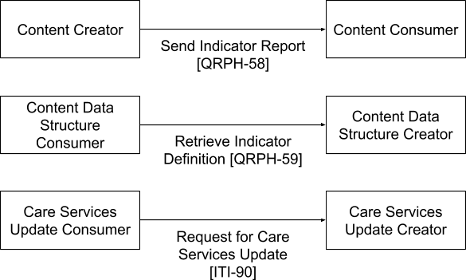

Figure X.1-1: mADX Actor Diagram
Table X.1-1 lists the content module(s) defined in the mADX Profile. To claim support for this profile, an actor shall support all required content modules (labeled “R”) and may support optional content modules (labeled “O”).
Table X.1-1: mADX Profile - Actors and Content Modules
Actors | Content Modules | Optionality | Reference
Content Data Structure Creator | mADX/DSD | R | QRPH TF-3: Sec 8.2-8.3, App. 8A, 8E
Content Data Structure Consumer | mADX/DSD | R | QRPH TF-3: Sec 8.2-8.3, App. 8A, 8E
Content Creator | mADX message | R | QRPH TF-3: App 8G
Content Consumer | mADX message | R | QRPH TF-3: App 8G
Care Services Update Supplier | mCSD/ Request for Care Services Updates | R | ITI mCSD: Sec 46.1
Care Services Update Consumer | mCSD/ Request for Care Services Updates | R | ITI mCSD: Sec 46.1

X.1.1 Actor Descriptions and Actor Profile Requirements

X.1.1.1 Content Data Structure Creator
The mADX Profile defines the process for a Content Data Structure Creator to develop a mADX/DSD which describes the base constraints for a valid mADX data message and any required code sets for disaggregation dimensions of the reported value.
Individual jurisdictions may extend the mADX/DSD by specifying relevant code sets and additional dimensions of data to satisfy their message exchange use cases.
A Content Data Structure Creator defines a Measure Resourceto be exchanged between a Content Creator and Content Consumer. Typically, the Content Data Structure Creator will be an implementing jurisdiction such as a ministry of health, a global non-government organization (NGO) or a donor.
A Content Data Structure Creator shall create a normative mADX/DSD. The mADX/DSD shall be available as a HL7 FHIR Measure resource. The HL7 FHIR Measure resource shall reference HL7 FHIR Value Sets from a compliant HL7 FHIR Terminology Service. These HL7 FHIR Values Sets shall include the allowed codes for additional non-spatial disaggregation dimensions.

X.1.1.2 Content Data Structure Consumer
A Content Data Structure Consumer consumes a mADX/DSD resource produced by a Content Data Structure Creator. The system implementing this actor role will often be a Content Creator, though this grouping is optional. The mADX/DSD can be used to configure the Content Creator to produce valid content.

- The Content Data Structure Consumer SHALL retrieve a Data Structure Definition by executing a Retrieve Indicator Definition [QRPH-59] as defined in this profile.

- The Content Creator or the Content Consumer may act as a Content Data Structure Consumer, view X.3 Required Actor Groupings

X.1.1.3 Content Creator
A Content Creator SHALL be able to generate an XML file that is conformant to the mADX/DSD and can transmit a mADX message to the Content Consumer. A Content Creator, under the Validate mADX Option, shall be grouped with a Care Services Update Consumer and a Content Data Structure Consumer.

X.1.1.4 Content Consumer
A Content Consumer SHALL be able to process a data stream that is conformant to the format defined by the mADX/DSD and schemas produced by the Content Data Structure Creator. What it means to process the XML stream depends on the nature of the processor. For example it might persist the individual data tuples, or it might format them for display or perform further aggregation on the data. A Content Consumer, under the Validate mADX Option, SHALL be grouped with a Care Services Update Consumer and a Content Data Structure Consumer.

X.1.1.5 Care Services Update Supplier
The Care Services Update Supplier is defined in the mCSD Profile in X.1.
mADX leverages location services from Care Services Update Supplier.
The Care Services Update Supplier provides the set of valid spatial dimensions as HL7 FHIR locations and is the source of the location data referenced in an ADX message. The list of valid locations is determined by the implementing jurisdiction.

X.1.1.6 Care Services Update Consumer
The Care Services Update Consumer is defined in the mCSD Profile in Section X.1.

X.2 mADX Actor Options
Table X.2-1: mADX - Actors and Options
Actor | Option Name | Reference
Content Data Structure Creator | No options defined | --
Content Data Structure Consumer | Validate mADX message | X.2.1
Content Creator | No options defined | --
Content Consumer | No options defined

X.2.1 Validate mADX Option
The Content Creator or Content Consumer Actors, SHALL be grouped with the Content Data Structure Consumer and the mCSD Care Services Updates Consumer if the Validate mADX message Option is used, which includes the Retrieve Indicator Definition [QRPH-59] transaction.

X.3 mADX Required Actor Groupings
There are no Required Actor Groupings defined except in the Validate mADX Option where the Content Creator or Content Consumer Actors, SHALL be grouped with the Content Data Structure Consumer and the mCSD Care Services Updates Consumer as indicated in X.2.1

X.4 mADX Overview
mADX defines a mADX/DSD conformant to the HL7 FHIR Measure Resource. The mADX/DSD defines the metadata needed to validate a mADX message for representing aggregate health data. More information on the characteristics of data being sent in a mADX message is provided in Section X.4 of the ADX Profile.
This profile sets constraints on the mandatory dimensions which shall be in a mADX/DSD. Additional data element dimensions may be defined as necessary within the context of use - for example, within a particular country or implementing jurisdiction. Similarly, whereas mADX assumes that code sets and other structural metadata will be shared with Content Creators and Content Consumers under the Validate Option as described in X.2.1. These inputs to the mADX message schema definition are conceptually illustrated by Figure X.4-1 in which the Content Creator and Content Consumer are both enacting the Validate mADX Option.

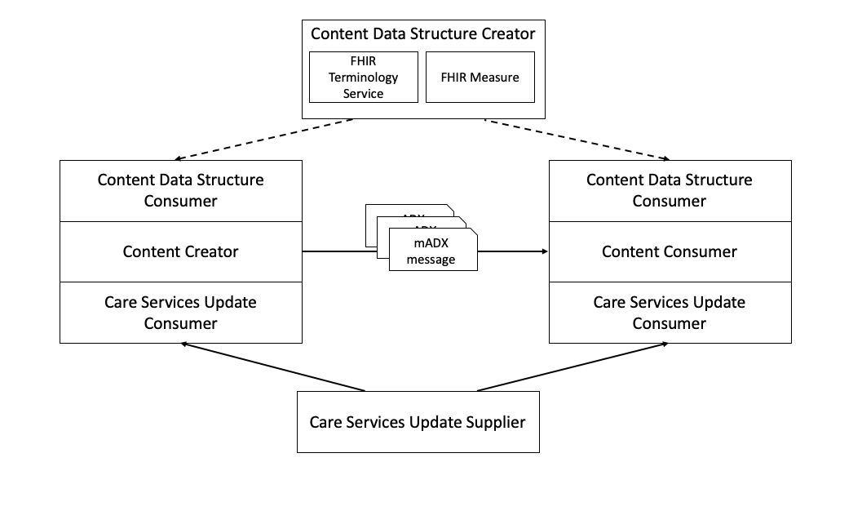
Figure X.4-1: An illustration of mADX Profile inputs and outputs

X.4.1 Concepts
The following concepts are used in this profile:
- Data Structure Definition (DSD): Refer to Section X.4.1 of the ADX Profile.
- Data value: Refer to Section X.4.1 of the ADX Profile.
- Data Value Set: Section X.4.1 of the ADX Profile. In mADX these should be contained in the mADX message sent by the Content Creator.
- Data element: Refer to Section X.4.1 of the ADX Profile.
- Measure: The FHIR resource by which a formal definition of the structural metadata of a mADX message is created. FHIR Measure is the base data model being profiled in mADX for defining the DSD. A Measure MAY contain multiple defined indicators in a group.
- MeasureReport: The FHIR resource that specifies a given Data Value Set that conforms to its related FHIR Measure.
- Organization Unit: Refer to Section X.4.1 of the ADX Profile. Note that Organization Unit may encompass the mCSD Location
- Person-centric Health Information (PHI): Is any information that can be used to identify an individual.
- Time: Refer to Section X.4.1 of the ADX Profile.
- Value: Refer to Section X.4.1 of the ADX Profile.

X.4.2 Use Cases
The use cases that mADX is solving are the same as those defined in Section X.4.2 of the ADX Profile with the exception of the mADX validation use case described in X.4.2.1 and X.4.2.2.
X.4.2.1 Validation by Content Creator
A local hospital in Senegal may be submitting data to the national level Health Management Information System (HMIS) via mADX indicator message. Before submitting the data to the HMIS the hospital system will make several queries to ensure that it has the most up to date versions of the mADX Data Structure Definition, terminology, and provider lists. This action is similar to the ADX Use Case X.4.2.2.1Reporting health worker data Use Case Description. The hospital system may run these in a loop to validate multiple messages against the same set of resources.After validating all three elements, the hospital system will submit the mADX indicator message to the national HMIS. In this use case the Content Creator and Content Data Structure Consumer are grouped.
In this use case the local hospital system is acting as the Content Creator and Content Data Structure Consumer, while the national HMIS is the Content Consumer.
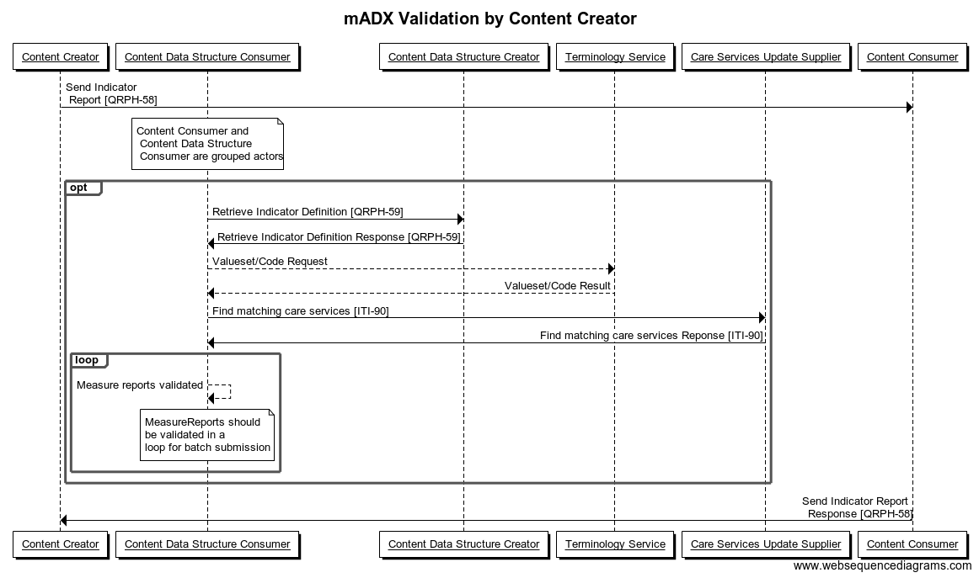

Actor Group
Figure X.4.2.1-1: mADX Validation by Content Creator

X.4.2.2 Validation by Content Consumer

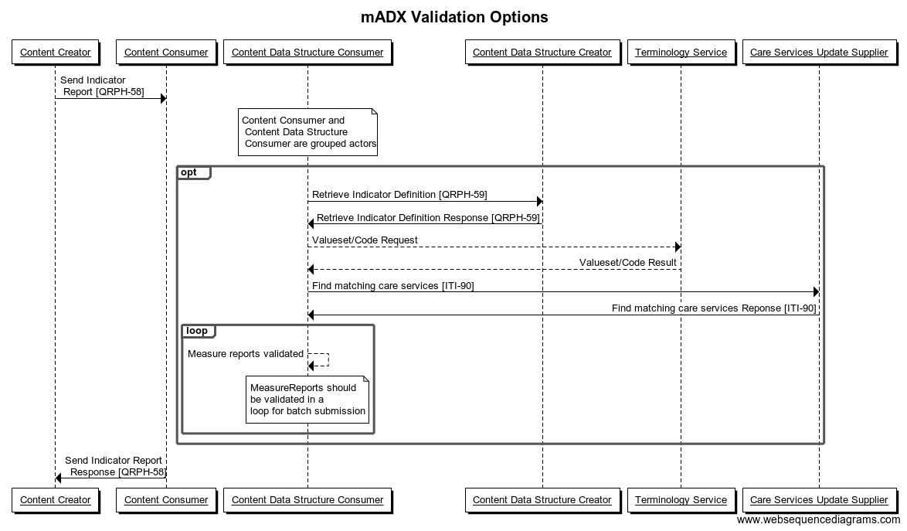
Actor Group

Figure X.4.2.2-1: mADX Validation by Content Consumer
In Tanzania, a state level HMIS has collected a month of data and needs to push it to the national level HMIS. The state HMIS acts a Content Creator to submit an indicator as a MeasureReport to the national level HMIS acting as a Content Consumer.
Upon receipt of the data the national level HMIS will validate the message against the Data Structure Definition they were created against, the terminology codes against a terminology server, and the location list to ensure that all reporting locations are correctly referenced in the indicator MeasureReport. Like the previous use case X.4.2.1, this validation may be done in a loop to validate a batch of resources.
After validation of the message is complete the national HMIS returns a confirmation.

X.5 mADX Security Considerations
The mADX Profile does not support the exchange of personally identifiable information. Therefore, this profile does not specify security mechanisms, such as the ITI Audit Trail and Node Authentication (ATNA) Profile, that would be required were that the case. Implementers should nevertheless be sensitive to the possibility of approximate personal identification arising from aggregate data derived from small population sets. Transport of such data should be safeguarded according to jurisdictional guidelines.

X.6 mADX Cross Profile Considerations

X.6.1 Aggregate Data Exchange (ADX)
mADX subsumes the functionality of ADX in a FHIR format and expands it.

X.6.1.1 The Mobile Care Services Discovery (mCSD)
The Mobile Care Services Discovery (mCSD) Profile supports RESTful queries for organization units via the FHIR Location resource. Locations are physical care delivery sites such as hospitals, clinics, health outposts, physician offices, labs, pharmacies. Locations also include political administrative area, such as a village district or region. A Location has a unique identifier and may have geographic attributes (address, geocode), contact attributes, and other attributes such as hours of operation. This location data is made available via the Request for Care Services Updates transaction initiated by a Care Services Update Consumer against a Care Services Update Supplier. See ITI TF-2x: Appendix Z.8 for common mobile security considerations.
Under the X.2.2 Validate mADX Option, a Content Creator or a Content Consumer shall be grouped with the Care Services Update Consumer to ensure that it has an updated list of the resources for the reporting locations. The list may be used to validate the reporting locations sending MeasureReports under the validation option described in this profile.
Additionally, a Care Services Update Supplier that contains information on health care practitioners can also be used to generate a mADX message to satisfy the use case X.4.2.2. of ADX in which a district health manager running an aggregate report on staffing levels by location and health care practitioner role.

Appendices
None

Volume 2 – Transactions
Add Section 3.35

3.58 Send Indicator Report [QRPH-58]
This section corresponds to transaction [QRPH-58] of the IHE QRPH Technical Framework. Transaction [QRPH-58] is used by the Content Creator and Content Consumer Actors to share aggregate health data within a jurisdiction using a FHIR MeasureReport.

3.58.1 Scope
This transaction is used to communicate aggregate health data from the Content Creator to the Content Consumer at the end of each reporting cycle.

3.58.2 Actor Roles

Send Indicator Report [QRPH-58]
Content Creator
Content Consumer
Figure 3.58.2-1: Use Case Diagram
The roles in this transaction are defined in the following table and may be played by the actors shown here:
Table 3.58.2-1: Actor Roles
Actor: | Content Creator
Role: | The Content Creator is responsible for the creation of a mADX message containing aggregate health data conformant to the jurisdiction defined mADX DSD and transmitting this message to a Content Consumer.
Actor: | Content Consumer
Role: | A Content Consumer is responsible for receiving the mADX message containing aggregate health data conformant to the jurisdiction defined mADX DSD from the Content Creator and processing it.

3.58.3 Referenced Standards
- HL7 FHIR HTTP

3.58.4 Messages

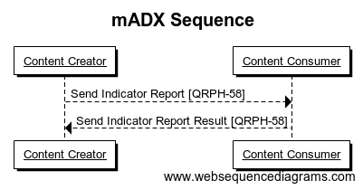
Figure 3.58.4-1: Send Indicator Report Diagram

3.58.4.1 Send Indicator Report
This transaction transmits mADX-conformant messages containing aggregate health data from the Content Creator to the Content Consumer. A Content Consumer implemented at a jurisdiction may receive this transaction from multiple Content Creators.
The Send Indicator Report is implemented as a FHIR Update Transaction defined in the RESTful API implementation guide: https://www.hl7.org/fhir/http.html#update.

3.58.4.1.1 Trigger Events
There are a wide variety of implementation and jurisdiction specific events which might trigger a Send Indicator Report transaction. This might be automated, for example a timeout indicating the end of a routine reporting period, or manually triggered in response to prevailing business logic. The trigger event is implementation specific.

3.58.4.1.2 Message Semantics
The Content Creator creates a mADX conformant message containing aggregate health data that meets the requirements of the mADX DSD in their jurisdiction. The Content Creator MAY send the message using Send Indicator Report. The Content Consumer SHALL consume the message that meets the requirements of the mADX DSD in their jurisdiction.
The table below describes the request.
Table 3.58.4.1.2-1: Messaging Semantics for Send Indicator Report
 | Description
URL | The mADX Profile does not prescribe the form of the URL to be advertised by a Content Consumer except that the scheme of the URL SHALL be “https”.  The following is a non-exhaustive list of valid examples:  - https://hmis.gov.rw/datasets/mADX  - https://hmis.gov.rw/routinereports/mADX  - https://hmis.gov.rw/routinereports
Headers | The Update request SHALL contain a Content-type header identifying the payload  - Type:Content-type: application/fhir+xml  - Type:Content-type: application/fhir+json  The request MAY contain any additional headers. For example, a Content Consumer may require an Authorization header.
 | A Content Consumer MAY support additional parameters.
BODY | The body of a mADX Send Indicator Report request SHALL contain a valid mADX data payload as described in Section 8.2 Data Structure Definition (DSD)
The indicator SHALL contain the following elements:
subject
A required location reference
period
The start and end of the reporting period
group.coding.code
A required reference for a valid indicator
stratifier.stratum.value
A required value for each reported aggregate report
stratifier.stratum.component
An optional value that should be present for each disaggregation dimensioned included in the report

3.58.4.1.3 Expected Actions
The Content Consumer SHALL processes the mADX message received and return the status of the transaction as a Send Indicator Report Result.

3.58.4.2 Send Indicator Report Result
This transaction is an acknowledgement of mADX POST Content transaction from the Content Consumer to the Content Creator.
The Send Indicator Report Result is implemented as an HTTP response. It can be emitted synchronously in response to the initial Update request, or maybe made available at a later time. The Content Consumer makes no guarantee that either the status URL or the result URL will be available permanently.

3.58.4.2.1 Trigger Events
A Content Consumer sends a Send Indicator Report Result after receiving and processing a Send Indicator Report from the Content Creator. For a synchronous request this will be the HTTP Response of the originating Request. For an asynchronous Request this will be in the HTTP Response of a later request that the Content Creator may make after polling for completion.

3.58.4.2.2 Message Semantics
The Send Indicator Report Result is implemented as an HTTP Response. The response may include content in the body to provide an implementation and jurisdiction specific informative message on the completed status of the transaction. The response shall contain an HTTP status code. The table below describes the codes which may be produced by the Content Consumer which have a specific meaning related to the transaction.
Note that a Content Creator should be prepared to handle additional status codes not particular to the transaction, such as authorization, server or network error codes. HTTP status codes correspond to FHIR HTTP 3.1.0.4.2 Rejecting Updates (https://www.hl7.org/fhir/http.html#rejecting-updates).
Table 3.58.4.2.2-1: Send Indicator Report Result status codes
HTTP status code | Interpretation
200 | Send Indicator Report Request was successfully processed
202 | Send Indicator Report Request has been accepted for processing, but the processing has not been completed. The request might or might not be eventually acted upon, and may be disallowed when processing occurs.
303 | The response to the Send Indicator Report when the task is complete can be retrieved from another URL. When received in response to a Send Indicator Report, the client should presume that the server has received the data and should issue a redirect with a separate GET message.
400 | Bad Request - message content is badly formed or invalid
401 | Not authorized - authorization is required for the interaction that was attempted
404 | Not found - resource type is not supported
405 | Method not allowed - the resource did not exist prior to the update, and the server does not allow client defined ids
409/412 | Conflict - invalid identifier in the message content.
415 | Unsupported content-type or media
422 | Unprocessable entity - The MeasureReport does not adhere to mADX Profile/data structure definition on the required fields, etc.
501 | The request method is not implemented.

3.58.4.2.3 Expected Actions
A Content Consumer SHALL respond with appropriate error codes in the event of receiving an invalid Submit Indicator Report Request according to the FHIR 3.1.0.4.2 Rejecting Updates.
If no other error conditions are encountered, a Content Consumer SHALL respond to a Submit Indicator Report Request with a 422 Unprocessable Entity and an appropriate OperationOutcome resource if any of the following business rule(s) are violated:
- The Submit Indicator Report Request message does not adhere to the message semantics as defined in Section 3.58.4.2.2 Message Semantics.
An OperationOutcome resource SHALL be generated for each MeasureReport resource submitted in the batch transaction which violates the above business rule(s), in which case the OperationOutcome SHALL:
- use response codes as in Table 3.58.EA-1 for the OperationOutcome.issue.code
- provide a FHIRPath identifying the invalid MeasureReport in OperationOutcome.issue.expression
- set the value of OperationOutcome.issue.expression to fatal.

3.58.5 Protocol Requirements
See ITI TF-2x: Appendix Z

3.58.6 Security Considerations
This profile assumes either implied or explicit data sharing agreements between the data exchange entities, and the envisaged use cases of the Send Indicator Report [QRPH-58] transaction, which do not include the exchange of PHI. Therefore, this transaction would not typically require security mechanisms that protects PHI, such as the ITI Audit Trail and Node Authentication (ATNA) Profile. Implementers SHOULD nevertheless be sensitive to the possibility of approximate personal identification arising from aggregate data derived from small population sets. In the instance where a quality measurement entity needs de-identified data, the IHE ITI Handbook on De-identification should be referenced.
Transport of mADX data SHOULD be safeguarded according to jurisdictional guidelines. To protect data integrity these SHOULD include encryption of the transport layer and the use of an appropriate mutual authentication mechanism which meets these guidelines.
Content Consumers should also take adequate account of security considerations related to the generic processing of mADX documents (RFC7303).

3.58.6.1 Security Audit Considerations
There is no specific ATNA security audit event that is associated with this transaction.

3.58.6.1.2 Actor Specific Security Considerations
NA

3.59 Retrieve Indicator Definition [QRPH-59]
This section corresponds to transaction [QRPH-59] of the IHE QRPH Technical Framework. Transaction [QRPH-59] is an optional transaction used by the Content Creator and Content Consumer Actors to retrieve the Data Structure Definition defined as a FHIR Measure using a FHIR methodology. It can be exercised as an optional validation step by implementers.

3.59.1 Scope
This transaction is used to obtain the Data Structure Definition in the form of a FHIR Measure in order to structure and validate a given FHIR MeasureReport.

3.59.2 Actor Roles

Retrieve Data Indicator Definition [QRPH-59]
Content Data Structure Creator
Content Consumer
Figure 3.59.2-1: Use Case Diagram
The roles in this transaction are defined in the following table and may be played by the actors shown here:
Table 3.59.2-1: Actor Roles
Actor: | Content Data Structure Creator
Role: | The Content Data Structure Creator is responsible for the creation of a mADX DSD, which a given mADX message SHALL conform
Actor: | Content Consumer
Role: | A Content Consumer is responsible for receiving the mADX DSD and validating its mADX messages.

3.59.3 Referenced Standards
- HL7 FHIR HTTP

3.59.4 Messages
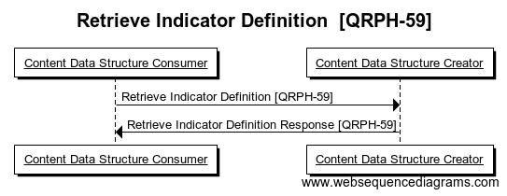

Figure 3.59.4-1: Interaction Diagram

3.59.4.1 Retrieve Indicator Definition
This transaction facilitates the Content Consumer requesting a mADX DSD from a Content Data Structure Creation. The DSD MAY be used by the Content Consumer to validate their mADX messages upon receipt.
The Retrieve Data Structure Definition is implemented as a FHIR Read transaction defined in the RESTful API implementation guide: https://www.hl7.org/fhir/http.html#read.

3.59.4.1.1 Trigger Events
A Content Consumer sends a Retrieve Data Structure Definition as a request for a given Data Structure Definition from a Content Data Structure Creator.

3.59.4.1.2 Message Semantics
Table 3.59.4.1.2-1: Messaging Semantics for Retrieve Indicator Definition
 | Description
URL | The mADX Profile does not prescribe the form of the URL to be advertised by a Content Consumer except that the scheme of the URL SHALL be “https”.
Headers | The Read request SHALL contain a Content-type header identifying the payload  Type:Content-type: application/ fhir+xml  Type:Content-type: application/fhir+json  The request MAY contain any additional headers. For example, a Content Creator may require an Authorization header.
BODY | The body of a mADX Retrieve Data Structure request SHALL contain the ID of the resource.

3.59.4.1.3 Expected Actions
The Content Consumer SHALL send a request for a given DSD from the Content Data Structure Creator.

3.59.4.2 Retrieve Indicator Definition Response
This transaction responds to the Content Consumer requesting a mADX DSD from a Content Data Structure Creator. The DSD SHALL be used by the Content Consumer to validate their mADX messages upon receipt.
The Retrieve Data Structure Definition Response is implemented as a FHIR Read transaction defined in the RESTful API implementation guide: https://www.hl7.org/fhir/http.html#read.
An example message is provided in Appendix 8C.

3.59.4.2.1 Trigger Events
A Content Data Structure Consumer SHALL return a Data Structure Definition Response if a Content Consumer has sent a Retrieve Data Structure Definition Request.

3.59.4.2.2 Message Semantics
The Content Data Structure Creator SHALL conform to HTTPS standards and respond to the Retrieve Indicator Definition Request with the appropriate status code outlined in the table below.
Table 3.59.4.2.2-1: Retrieve Indicator Definition Result status codes
HTTP status code | Interpretation
200 | Retrieve Indicator Definition Request was successfully processed
202 | Retrieve Indicator Definition Request has been accepted for processing, but the processing has not been completed. The request might or might not be eventually acted upon, and may be disallowed when processing occurs.
303 | The response to the Retrieve Indicator Definition Request when the task is complete can be retrieved from another URL. When received in response to a Retrieve Indicator Definition, the client should presume that the server has received the data and should issue a redirect with a separate GET message.
400 | Bad Request - message content is badly formed or invalid.
401 | Not authorized - authorization is required for the interaction that was attempted.
404 | Not found - The referenced Indicator Report/Measure resource was not found.
405 | Method not allowed - the resource did not exist prior to the update, and the server does not allow client defined ids.
409/412 | Conflict - invalid identifier in the message content.
415 | Unsupported content-type or media.
422 | Unprocessable entity - The referenced Indicator Report/Measure resource does not adhere to the message semantics of a Retrieve Indicator Definition [QRPH-59] transaction.
501 | The request method is not implemented.

The data structure definition response SHALL contain the following elements:
title
A human friendly name for this DSD.
Version
The business version of this DSD.
url
Where the definition of the DSD, and any updated versions, can be found.
publisher
The organization responsible for publishing and maintaining the DSD.
description
A narrative description of the scope of the DSD.
subject.subjectCodableConcept.coding[].code
Required to be set to patient, provider from the valueset https://www.hl7.org/fhir/valueset-subject-type.html. It will indicate the base resource in which the indicator is intended to run.
group[]
There should be a group element for each indicator that can be calculated based on the MDS defined in the DSD. Each group member should have a unique code defined, relative to the DSD.
group[].description
A narrative description of an indicator.
group[].code.coding[]
The "code" should be a unique code distinguishing the indicator within the DSD.
group[].stratifier[]
Contains the disaggregating value sets needed required for an indicator.
group[].stratifier[].component[]
There should be a “component” for each set of disaggregators which is linked to a FHIR ValueSet
group[].stratifier[].component[].code
A code used to reference this disaggregating valueset. There must be a relatedArtifact (see below) for each disaggregation set which is a reference to a FHIR Valueset
relatedArtifact[]
There should be a related artifact for each dissagregation set defined under group[].stratifier[].component[].
relatedArtifact[].label
The label should match one of the values of group[].stratifier[].component[].code for a disaggregation value set.
relatedArtifact[].url
The URL of a FHIR Valueset that defines the valid values reported in this disaggregation component as cross-referenced by relatedArtifact[].label
realatedArtifact[].type
Should be set to “depends-on”.

3.59.5.2.3 Expected Actions
The Content Data Structure Creator SHALL return the applicable DSD in the Data Structure Definition Response to the Content Consumer.

Appendices
None

Volume 2 Namespace Additions
Add the following terms to the IHE General Introduction Appendix G:

The QRPH registry of OIDs is located at https://wiki.ihe.net/index.php/QRPH_Registry

Volume 2 additions to the QRPH OID Registry are:
None

Volume 3 – Content Modules
NA

5 IHE Namespaces, Concept Domains and Vocabularies
Add to Section 5 IHE Namespaces, Concept Domains and Vocabularies

5.1 IHE Namespaces
The QRPH registry of OIDs is located at https://wiki.ihe.net/index.php/QRPH_Registry
Additions to the QRPH OID Registry are:

codeSystem | codeSystemName | Description
NA | NA | NA

5.2 IHE Concept Domains
NA

5.3 IHE Format Codes and Vocabularies

5.3.1 IHE Format Codes

List in the table below any new format codes to be added to the IHE Format Codes wiki page at http://wiki.ihe.net/index.php/IHE_Format_Codes. For public comment, the additions must be listed in the table below. The domain technical committee must ensure any new codes are also added to the wiki page prior to publication for trial implementation.

Profile | Format Code | Media Type | Template ID
NA | NA | NA | NA

5.3.2 IHEActCode Vocabulary

List in the table below, any new additions to the IHEActCode Vocabulary wiki page at http://wiki.ihe.net/index.php/IHEActCode_Vocabulary. For public comment, the additions must be listed in the table below. The domain technical committee must ensure any new codes are also added to the wiki page prior to publication for trial implementation.

Code | Description
NA | NA

5.3.3 IHERoleCode Vocabulary

List in the table below any new additions to the IHERoleCode Vocabulary wiki page at http://wiki.ihe.net/index.php/IHERoleCode_Vocabulary. For public comment, the additions must be listed in the table below. The domain technical committee must ensure any new codes are also added to the wiki page prior to publication for trial implementation.

Code | Description
NA | NA

6 Content Modules
NA

7 DICOM® Content Definitions
NA

8 mADX Content Modules
This section defines Content Modules for the Aggregate Data Exchange (mADX) Profile.

8.1 Overview of mADX process
A Content Data Structure Creator creates mADX-conformant DSD and schema streams. Typically, the mADX Content Data Structure Creator will be an implementing jurisdiction such as a ministry of health, a global non-government organization (NGO) or a donor.
- A mADX compliant DSD is a profile of the HL7 FHIR SDMX 2.1 DSD, as described in Section 8.2 and formally expressed as a Schematron rule set in Appendix 8A.
- mADX Content data messages can be validated using valuesets from the HL7 FHIR Terminology Service. Normative XSLT 1.0 stylesheets are provided in Appendices 8B and 8D to generate a W3C XML schema definition and an ISO Schematron schema. Sample mADX compliant schema is provided in the informative Appendix 8G and 8H.
Content Creators and Content Consumers exchange a data payload that conforms to the mADX compliant schemas. A sample mADX compliant data payload is provided in the informative Appendix 8I.
Additional (informative) message constraints for interoperability of mADX data exchange which are outside of the scope of this profile are described in Section 8.4.

8.2 Data Structure Definition (DSD)
A mADX compliant DSD shall be all of:
- FHIR Measure Report
- with the additional constraints defined below.
The purpose of profiling the base DSD is to provide guidance regarding which parts of a mADX DSD are fixed by the profile and which parts may be extended to support implementation-specific requirements.

8.3 mADX Message Exchange Constraints (Informative)
There are implicit assumptions regarding the sharing of additional metadata between Content Creators and Content Consumers which are not covered within the scope of the mADX Profile. In order to ensure semantic validity of the exchanged data, the constraints described below shall be specified using processes not defined by this profile:
- The data elements to be reported for particular Organizational Units. For example, reporting ‘Number of lab Tests performed’ from a health facility which did not perform laboratory tests is not constrained by mADX.
- The Value type (real or integer) expected for individual data elements.
- Which period types are appropriate for which data elements.
The preceding is not an exhaustive list. Other business rules that may affect interoperability may need to be established such as bounds on data values, bounds on date ranges, relationships between different data elements (e.g., the sum of these data elements cannot be greater than the sum of those data elements, etc.

Appendices to Section 8

Appendix 8A – FHIR Profile on Terminologies
An electronic copy of the file is available at https://www.hl7.org/FHIR/terminology-service.html

Appendix 8B – (Informative) Sample mADX Measure
An electronic copy of the file is available at..

{
"resourceType": "Measure",
"id": "madx-hiv-indicators-example",
"title": "HIV",
"version": "0.0.0",
"publisher" : "ohie.org",
"description" : "EXAMPLE indicators supporting OpenHIE implementations of the IHE ADX-HIV content profile",
"subject" : {
"coding" : [
{
"system" : "http://hl7.org/fhir/ValueSet/subject-type",
"code" : "Patient"
}
]
},
"group" : [
{
"code" : "QRPH_ADX_ART1_N",
"description" : "Number of adults and children newly enrolled on antiretroviral therapy (ART)",
"stratifier" : [
{
"component" : [
{
"code" : {
"coding" : [
{
"system" : "http://ihe.net/qrph/madx-example-components",
"code" "AGE_GROUP"
}
]
}
},
{
"code" : {
"coding" : [
{
"system" : "http://ihe.net/qrph/adx-example-components",
"code" "SEX"
}
]
}
}
]
}
]
}
],
"relatedArtifact" : [
{
"label" : "AGE_GROUP",
"url" : "http://ihe.net/qrph/adx-hiv-example-age-groups",
"type" : "depends-on"

},
{
"label" : "SEX",
"url" : "http://ihe.net/qrph/adx-hiv-example-sex",
"type" : "depends-on"

},
],
"url": "http://ohie.org/Measure/madx-hiv-indicators-example",
"identifier": [
{
"system": "http://ohie.org/Measure/",
"value": "madx-hiv-indicators-example"
}
],
"status": "draft",
"experimental": true,
"date": "2019-08-02",
}

Appendix 8C – (Informative) Sample mADX message
An electronic copy of the file is available at

{
"resourceType": "MeasureReport",
"measure": "http://ohie.org/Measure/madx-hiv-indicators-example",
"id" : "12345-example",
"period": {
"start": "2018-01-01",
"end": "2018-01-31"
},
"group": [
{
"code": {
"coding": [
{
"code": "QRPH_ADX_ART1_N"
}
]
},
"stratifier": [
{
"stratum": [
{
"measureScore": {
"value": 5
},
"component": [
{
"code": {
"coding": [
{
"code": "AGE_GROUP"
}
]
},
"value": {
"coding": [
{
"system" : "http://ihe.net/qrph/adx-hiv-example-age-group",
"code": "P0Y--P1Y"
}
]
}
},
{
"code": {
"coding": [
{
"code": "SEX"
}
]
},
"value": {
"coding": [
{
"system" : "http://ihe.net/qrph/adx-hiv-example-sex",
"code": "F"
}
]
}
}
]
}
]
}
]
}
]
}

}

Volume 4 – National Extensions
Not applicable

HL7 is the registered trademark of Health Level Seven International.
FHIR is the registered trademark of Health Level Seven International.
DICOM is the registered trademark of the National Electrical Manufacturers Association for its standards publications relating to digital communications of medical information.

