# IHE Work Item Proposal (Detailed)

## Proposed Work Item: eReferral Search Services (eRSS)

Proposal Editors: Derek Ritz (ecGroup; openHIE) & Ron Parker (Canada Health Infoway)

Work Item Editors: Derek Ritz (ecGroup; openHIE) & Ron Parker (Canada Health Infoway)

Date: 19 November 2012

Version: 0.4

Domain: IT Infrastructure

## Summary

In a distributed health care delivery environment, one that encompasses a number of different provider organizations and service delivery locations, there is an unmet need to support the referral of clients to the “appropriate” combination of care resource, facility, provider and organization. This requirement for timely and effective referral is found in developing countries and in developed countries; the project team will be made up of participants from both of these cohorts. Satisfying this requirement is challenging because there is a many-to-many (M:M) relationship between providers and organizations; there is a M:M relationship between organizations and locations; and there is a M:M relationship between locations and care resources. This proposed work item will address the “M:M” challenge and support the target use cases by providing a mechanism to:

1. Describe the eReferral Search Services (eRSS) client query and server response functionality
2. Establish and maintain the underlying registry information for the core entities
3. Establish and maintain the relationships between these registries
4. Provide a slot-based mechanism to support rudimentary scheduling of combinations of providers & facilities and of care resources & facilities.

The present work item will operate within the context of existing IHE profiles. It is expected that the proposed profile will support the use cases and interactions defined for the PWP and HPD profiles. It is also expected that the proposed profile could usefully support clinician queries upstream of launching an XDW-supported referral process. Lastly, the profile will not make assumptions regarding the presence or absence of intermediary architecture such as a health information access layer (HIAL) or HIE; it will support both bus-supported and direct point-to-point deployments.

## The Problem

In many scenarios, a client must be referred to an escalated or specialized level of care. There may be a requirement for specific equipment and/or specialized clinicians, depending on the situation. In order to effect such a referral, there must be a mechanism to determine where such equipment and/or providers are to be found – and when.

In certain cases, there will be a preference for the “soonest” availability or for the “nearest” location – or (more typically) some combination of these. Ultimately, such a referral will consume the capacity of a particular combination of provider, organization and care resource at a particular location at a particular time.

The problem is that, today, this cannot be readily accomplished with existing methods. Uses of fax, telephone, and paper mail or couriers are still the prevailing method. These methods require a significant amount of human intervention, are error prone, typically have significant latency built into the processes, and work within the limitations of the clinician or patient’s knowledge of available resources. There is not a mechanism to establish and maintain these lists of resources and their relationships; to query them; and to allocate (or book) the capacity they represent. This problem is addressed by the proposed new profile.

Using the proposed profile, a number of important queries can be executed:

* When is the soonest time, within a 10km distance from here, that a maternal clinic is operating? Where and when is this clinic?
* Where is the closest location where a specific type of specialist has an available appointment within the next 2 weeks? Where is this specialist’s office, who is the specialist, and what appointment slots are available?
* Where is the closest location that a specific clinical service is provided (care resource, e.g. x-ray) and when is the soonest time slot available?

Solving this scheduling problem also solves a number of important “subset” problems. There is not, today, a ready mechanism to query the “combinations” of providers, organizations, facilities and resources. Such functionality supports scheduling plus it enables discovery (e.g. Tanzania use cases; ONC Consumer Empowerment use cases) and can be used to support secure communication (e.g. HHS’s Direct Connect programme). It is expected that the proposed profile will elegantly address these non-scheduling requirements as well.

## Use Cases

There are two key “flavours” of use case that will leverage the registry linkages:

1. Querying and allocating capacity of care resources at facilities
2. Querying and allocating capacity of providers at facilities.

From these two sentinel use cases, a number of administrative use cases arise in order to establish and maintain the underlying registry information and the relationships between these registries. The management and querying of these is not unimportant and these are valuable use cases in their own right; however, the primary use cases are those supporting the scheduling of care escalation and referral (be it to a specific provider or to a programme or service).

### Sentinel Use Case 1: Querying & Allocating Resources at a Facility

The following user story is based on requirements from a national eHealth infrastructure being deployed in Rwanda.

* Mosa is a young pregnant woman; she is being seen by a community health worker, Grace, who is conducting Mosa’s 2nd antenatal care (ANC) visit.
* Grace records ANC observations using SMS on her mobile phone.
* Mosa’s blood pressure reading is high; she should be referred to see a clinician.
* The cloud-based mHealth application queries an eReferral Search Service to determine the closest facility (geo-coded Facility Registry) offering maternal care services (Resource Registry) within a specific timeframe (Resource Registry / Facility Registry calendar).
* An SMS reply from the mHealth service indicates to Grace that maternal clinics operate on Tuesdays and Thursdays at the health facility closest to Mosa’s village.
* Grace prepares a referral note for Mosa. Mosa is automatically added to the patient queue for the next maternal clinic at the facility.

This user story is illustrated by the diagram shown in Figure 1.

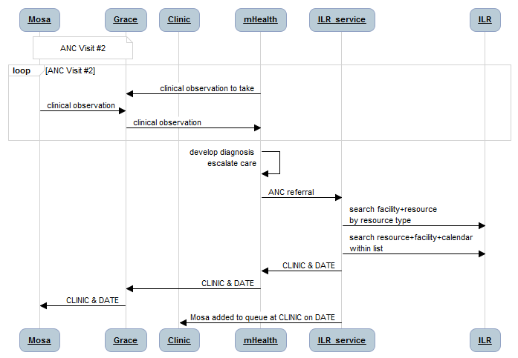

*Figure 1 – Querying & Allocating Resources at a Facility*

### Sentinel Use Case 2: Querying & Allocating Providers at a Facility

The following user story is taken from a Canada Health Infoway document describing the need, as has been expressed by jurisdictions in Canada, for “interdependent registries”.

* David Lambert sees his family physician, Dr. Black, regarding a recent knee injury.
* Dr. Black diagnoses the problem as a torn ACL and decides to refer David to an orthopedic surgeon.
* Dr. Black uses his EMR to search for orthopedic surgeons; a list is returned sorted by available consult timeslot (soonest to latest) and by location (closest to farthest).
* After discussing the options with David, Dr. Black chooses Dr. Bone from the list and a “pending referral” is automatically created.
* David returns home. Later that day, Dr. Bone’s office reviews the pending referral and accepts it. A “scheduled referral” message is communicated to Dr. Black and to David.

The user story is illustrated by the diagram shown in Figure 2.

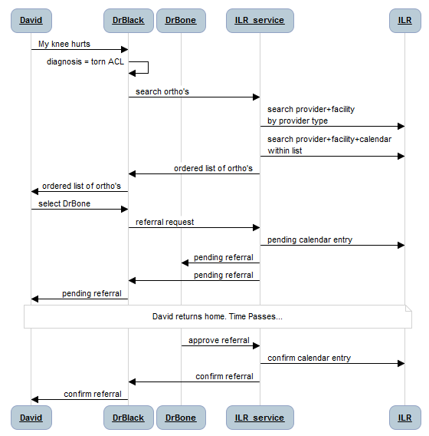

*Figure 2 – Querying & Allocating a Provider at a Facility*

### Supporting Use Cases

In order to support the sentinel use cases, it must be possible to establish and maintain the information in the registries and to establish and maintain the relationships between data in them. As such, there must be a mechanism to put, list, update and get (PLUG) data into each of the four defined registries. In addition, there must be PLUG capability for important combinations (relationships). In all, the following PLUGs are needed:

* Facility
* Resource
* Organization
* Provider
* Resource + Facility
* Provider + Facility
* Provider + Organization
* Organization + Facility
* Slots (Calendar-based Availability) for Resource + Facility
* Slots (Calendar-based Availability) for Provider + Facility
* Slots (Calendar-based Availability) for Provider + Resource + Facility

## Standards & Systems

It is proposed that this work item will heavily leverage the Human Services Directory (HSD) Functional Specification jointly developed by HL7/OMG, including the data dictionary included as an appendix to this specification. The HSD spec outlines, in detail, a set of services which may be employed to satisfy the use cases defined in the previous section. A copy of this specification is appended to this document.

It is proposed that 2 message specifications will be supported by the profile. Significant work has already been done within the HL7 community to map SOAP-based HL7v3 messages to the HSD service functional model and this work will be extended by Infoway. An overview of these mapped HL7 messages is included in the transaction table listed later in this document.

The openHIE community is focused on development and deployment to resource-constrained countries. This community will develop a compatible, alternative API based on REST, JSON and XML (perhaps leveraging hData) also leveraging the same HSD specifications. Such an API will be more readily consumed by the in-country IT community thereby encouraging democratization of health related information. This latter set of interfaces will be more consistent with the approach which has been favoured by the MHD profile.

The Provider Registry partner in the openHIE consortium, IntraHealth International, has explored the existing PWP and HPD profiles and expects to support them natively. For consistency, it is expected that the RESTful, JSON and XML-based interactions defined in the eRSS profiles may (optionally) also support PWP and HPD via a façade pattern. In this way, the eRSS profile will provide a superset of the features of the existing PWP and HPD profiles and maintain backward compatibility with them.

## Technical Approach

The many-to-many relationship between registries is illustrated in Figure 3. As shown by this figure, a focus on managing the interrelationships between these registries implies the management of the four underlying registries themselves. Such management is conceptualized as supporting a “PLUG” (put, list, update and get).

Each put-list-update-get (PLUG) will embrace a similar pattern, whether the interfaces are HL7v3 based or RESTful. It is important to note that the REST approach proposed in this profile is analogous to the approach used by the MHD profile; further, it should be noted that the proposed OAuth profile would impact the REST based API contemplated for this profile in the same way that it impacts MHD.

An approach leveraging schedulable “slots” for the combinations of Resources @ Facilities and Providers @ Facilities is illustrated by Figure 4. Similarly, we will evaluate the feasibility of implementing a PLUG for each set of slots. Also, we will also explore a “compound” P+R+F slot as the “Venn diagram” overlap of the F+ P and F+R slots.



*Figure 3 – Interrelated Registries*



*Figure 4 – Schedulable Time Slots*

#### New actors

**Registry Management Client** – the client application supporting Put-Get-Update

**Registry Management Server** – the server application supporting Put-Get-Update

**ILR Query Client** – the client application supporting interlinked registry List

**ILR Query Server** – the server application supporting List

**eReferral Scheduling Service (eRSS) client** – the client application that will allocate schedulable slots

**eReferral Scheduling Service (eRSS) server** – the server application that will allocate schedulable slots

#### Existing actors

We expect that the eRSS actors will naturally augment and/or group with XDW actors who are launching eReferral workflows and that the results of an eRSS allocation will inform the dates and times referenced in an eReferral document. We will also investigate how these actors may interact with or group with the Appointment Requestor and Appointment Scheduler actors defined in the IHE Eye Care Appointment Scheduling (ECAS) profile.

#### New transactions (standards used)

Because PLUG transactions will be specified for each of 4 registries and for 7 combinations of registries the list of new transactions is long. In many cases, though, the combinations represent “compound” transactions which may be made up of underlying primitives. There is also very strong coverage of existing HL7 transactions for these primitives (with the exception of Resource Registry transactions, for which there are not existing HL7 counterparts).

NOTE: the role of the GET transaction is to support UPDATE transactions. It is anticipated that, in order to UPDATE a record, the client would first retrieve the record (to ensure it has the current version of it) and then send the UPDATE to this record. Such a pattern would enable servers to maintain database consistency in a loosely-coupled, messaging environment. There is no technical difference between a LIST and GET except that it is expected, by convention, that a GET will return a single record only.

The following lists the anticipated new transactions:

|  |  |  |
| --- | --- | --- |
| Actor | Transaction | Example Standard(s) |
| Registry Management Client  Registry Management Server | Facility Registry PUT | HL7 V3 PA, R2  Interaction: Location Registry Add  Request (PRPA_IN202311UV02)  Model: Service Delivery Location  Activate  (PRPA_RM202301UV02) |
|  | Facility Registry GET | HL7v3 Location Details Query (PRLO_IN202012CA) |
|  | Facility Registry UPDATE | HL7 V3 PA, R2  Location Registry Revise Request  (PRPA_IN202314UV02)  Service Delivery Location Revise  (PRPA_RM202302UV02) |
|  | Provider Registry PUT | ANSI/HL7 V3 PM, R1-2005  Interaction: Add Provider Request  (PRPM_IN301010UV01)  Model: Provider Event Create  PRPM_RM301010UV01  IHE HPD |
|  | Provider Registry GET | ANSI/HL7 V3 PM, R1-2005 HL7  Interaction: Provider Details Query  (PRPM_IN306010UV01)  IHE PWP and HPD profiles |
|  | Provider Registry UPDATE | ANSI/HL7 V3 PM, R1-2005  Interaction: Update Provider  Request (PRPM_IN303010UV01)  Model: Update Provider  (PRPM_RM303000UV01)  IHE HPD |
|  | Resource Registry PUT |  |
|  | Resource Registry GET |  |
|  | Resource Registry UPDATE |  |
|  | Organization Registry PUT | ANSI/HL7 V3 PM, R1-2005  Interaction: Add Organization  Request (PRPM_IN401030UV01)  Model: Add Organization  (PRPM_RM401000UV01)  IHE HPD |
|  | Organization Registry GET | ANSI/HL7 V3 PM, R1-2005 HL7  Interaction: Organization Detail  Query (PRPM_IN406010UV01)  IHE HPD profile |
|  | Organization Registry UPDATE | ANSI/HL7 V3 PM, R1-2005  Interaction: Update Organization  Request (PRPM_IN403010UV01)  Model: Update Organization  (PRPM_RM403000UV01)  IHE HPD |
|  | Resource + Facility PUT |  |
|  | Resource + Facility GET |  |
|  | Resource + Facility UPDATE |  |
|  | Provider + Facility PUT | ANSI/HL7 V3 PM, R1-2005  Interaction: Update Provider  Request (PRPM_IN303010UV01)  Model: Update Provider  (PRPM_RM303000UV01) |
|  | Provider + Facility GET | ANSI/HL7 V3 PM, R1-2005 HL7  Interaction: Provider Details Query  (PRPM_IN306010UV01) |
|  | Provider + Facility UPDATE | ANSI/HL7 V3 PM, R1-2005  Interaction: Update Provider  Request (PRPM_IN303010UV01)  Model: Update Provider  (PRPM_RM303000UV01) |
|  | Organization + Facility PUT | ANSI/HL7 V3 PM, R1-2005  Interaction: Update Organization  Request (PRPM_IN403010UV01)  Model: Update Organization  (PRPM_RM403000UV01) |
|  | Organization + Facility GET | ANSI/HL7 V3 PM, R1-2005 HL7  Interaction: Organization Detail Query (PRPM_IN406010UV01) |
|  | Organization + Facility UPDATE | ANSI/HL7 V3 PM, R1-2005  Interaction: Update Organization  Request (PRPM_IN403010UV01)  Model: Update Organization  (PRPM_RM403000UV01) |
|  | Provider + Organization PUT | ANSI/HL7 V3 PM, R1-2005  Interaction: Update Provider  Request (PRPM_IN303010UV01)  Model: Update Provider  (PRPM_RM303000UV01) |
|  | Provider + Organization GET | ANSI/HL7 V3 PM, R1-2005 HL7  Interaction: Provider Details Query  (PRPM_IN306010UV01)  IHE HPD profile |
|  | Provider + Organization UPDATE | ANSI/HL7 V3 PM, R1-2005  Interaction: Update Provider  Request (PRPM_IN303010UV01)  Model: Update Provider  (PRPM_RM303000UV01) |
|  | R+F Slot PUT | HL7 V3 SC, R2, 2007Sep Ballot  Interaction: New Appointment Slot  Request (PRSC_IN030101UV)  Model: Slot Intent Create Request  PRSC_MT050101UV |
|  | R+F Slot GET | ANSI/HL7 2.6-2007, Chapter 10 –  Scheduling |
|  | R+F Slot UPDATE | HL7 V3 SC, R2, 2007Sep Ballot  Interaction: Slot Status Revise Request  (PRSC_IN020301UV)  Model: Slot Intent Revise  PRSC_MT040101UV |
|  | P+F Slot PUT | HL7 V3 SC, R2, 2007Sep Ballot  Interaction: New Appointment Slot  Request (PRSC_IN030101UV)  Model: Slot Intent Create Request  PRSC_MT050101UV |
|  | P+F Slot GET | ANSI/HL7 2.6-2007, Chapter 10 –  Scheduling |
|  | P+F Slot UPDATE | HL7 V3 SC, R2, 2007Sep Ballot  Interaction: Slot Status Revise Request  (PRSC_IN020301UV)  Model: Slot Intent Revise  PRSC_MT040101UV |
| ILR Query Client  ILR Query Server | Facility Registry LIST | HL7v3 Location Summary Query  (PRLO_IN202010CA) |
|  | Resource Registry LIST |  |
|  | Provider Registry LIST | ANSI/HL7 V3 PM, R1-2005 HL7  Interaction: Provider Details Query  (PRPM_IN306010UV01)  IHE PWP and HPD profiles |
|  | Organization Registry LIST | ANSI/HL7 V3 PM, R1-2005 HL7  Interaction: Organization Detail  Query (PRPM_IN406010UV01)  IHE HPD profile |
|  | Resource + Facility LIST |  |
|  | Provider + Facility LIST | ANSI/HL7 V3 PM, R1-2005 HL7  Interaction: Provider Details Query  (PRPM_IN306010UV01) |
|  | Organization + Facility LIST | ANSI/HL7 V3 PM, R1-2005 HL7  Interaction: Organization Detail  Query (PRPM_IN406010UV01) |
|  | Provider + Organization LIST | ANSI/HL7 V3 PM, R1-2005 HL7  Interaction: Provider Details Query  (PRPM_IN306010UV01)  IHE HPD profile |
|  | Provider Slot LIST | ANSI/HL7 2.6-2007, Chapter 10 –  Scheduling |
|  | Resource Slot LIST | ANSI/HL7 2.6-2007, Chapter 10 –  Scheduling |
|  | Facility Slot LIST | ANSI/HL7 2.6-2007, Chapter 10 –  Scheduling |
|  | R+F Slot LIST | ANSI/HL7 2.6-2007, Chapter 10 –  Scheduling |
|  | P+F Slot LIST | ANSI/HL7 2.6-2007, Chapter 10 –  Scheduling |
|  | P+R+F Slot LIST | ANSI/HL7 2.6-2007, Chapter 10 –  Scheduling |
| eRSS Client  eRSS Server | P+F Slot ALLOCATE | HL7 V3 SC, R2, 2007Sep Ballot  Interaction: New Appointment  Notification (PRSC_IN010101UV01)  Model: Appointment Intent New  Notification PRSC_MT010101UV  ANSI/HL7 2.6-2007, Chapter 10 –  Scheduling |
|  | R+F Slot ALLOCATE | ANSI/HL7 2.6-2007, Chapter 10 –  Scheduling |
|  | P+R+F Slot ALLOCATE | ANSI/HL7 2.6-2007, Chapter 10 –  Scheduling |

The data models for each transaction, and indeed the behaviours of the transactions themselves are described in detail within the HL7/OMG HSD specification (appended).

It is expected that existing registries will readily support their “natural” transaction sets. For example, a Facility Registry will easily support PLUG on its facility (location) data and likewise, a Provider Registry will support PLUG on its provider data. Because of the natural nature of the combinations, it is anticipated that a Facility Registry would also support the Resource Registry interactions. This is reflective of the typical functionality found today in such registries where resources located at a facility and “attributes” of a facility are already tracked and managed. It is expected, then, that such a F|R registry would “naturally” support:

* Facility Registry PLUG
* Resource Registry PLUG
* Facility + Resource PLUG

Similarly, it is expected that Provider Registries would be natural supporters of Organization Registry interactions as this is typically included in their “footprint” today. An HPD compliant Provider Registry is a good example of this. Analogous to the F|R description, above, such a P|O registry would “naturally” support:

* Provider Registry PLUG
* Organization Registry PLUG
* Provider + Organization PLUG

If one assumes these natural combinations (P|O, F|R), then the following might be possible configurations:

* P|O being a **Registry Management Server** actor for its own “natural” interactions, plus exposing Provider + Facility PUG, Organization + Facility PUG and P+F Slot PUG transactions as *compound* transactions. It would accomplish this by being an **ILR Query Client** of Facility Registry LIST and Facility Slot LIST transactions.
* F|R being a **Registry Management Server** actor for its own “natural” interactions, plus exposing P+F Slot PUG transactions as *compound* transactions. It would accomplish this by being an **ILR Query** **Client** of the Provider Slot LIST transaction.
* Either a P|O server or an F|R server, if configured as above, could choose to be an **eRSS Server** actor by adding a slot management capability to support the P+F Slot ALLOCATE transaction.
* For a P|O server to be an **eRSS Server** actor able to support the P+R+F Slot ALLOCATE transaction it would need to be an **ILR Query Client** actor supporting Facility Slot LIST and Resource Slot LIST transactions (or of R+F Slot LIST transactions, if those were supported by any available **ILR Query Server** actors).
* An orchestrating intermediary, such as a HIAL or HIE, could be a **Registry Management Server**, **ILR Query Server** and **eRSS Server** actor to client applications. It would accomplish this by being, itself, a client of multiple registries and coordinating the compound transactions necessary to facilitate the combinatorial transactions.

#### Impact on existing integration profiles

In the face of façade transactions, the PWP and HPD profiles may be supported, unchanged by the proposed profile’s transactions. This supports backward compatibility with these profiles.

#### New integration profiles needed

A new profile will be created to describe the new actors and the new transactions.

#### Breakdown of tasks that need to be accomplished

The major work items to be performed are:

* Identify and evaluate the full suite of existing message standards available for each of the proposed transactions and attempt to determine the vendor adoption of each of these.
* Determine “light” (json, xml, hData) messages which align with existing HL7v3 standards
* Select standards for each transaction
* Develop “compound” transactions, as necessary, and define these using a rigorous orchestration language such as BPEL.
* Develop IHE-conformant documentation for the use cases supported by this profile
* Develop companion documentation (non normative) explaining alternate configurations of registries (somewhat based on the discussion, above, with appropriate diagrams and example transactions).

## Risks

The scope of this profile appears large and it will be important to divide it into digestible chunks for consumption by registry vendors. The permutations and combinations created by the interlinking of multiple registries can create complexity. It is crucial that the documentation explain that, in fact, these compound transactions are made up of a small number of primitive transactions – many of which are widely supported and mature. A failure to adequately partition transactions into smaller, familiar forms will significantly hamper vendor take-up of this profile.

There are few existing IHE transactions that refer to “resources”. Those that do (often referencing the HL7 v2 Chapter 10, Scheduling document) fail to unambiguously describe what care resources are. This flexibility is important, especially to the developing country use cases where a “resource” can mean a water point, an operating theatre, a maternal care programme or an orthopedic surgery service. However, the flexibility comes with the risk of imprecision and this can create substantial interoperability challenges. A risk analysis assessing the degree of flexibility that can be feasibly accommodated by the Resource Registry is necessary. It may be that greater specificity is needed to define the breadth of entities allowed in this registry (e.g., only physical things… with programmes in a separate registry, perhaps).

This profile is intended to be adaptable and adoptable in country contexts with both mature and nascent health information systems and health IT capacity. Team members focused on the resource-constrained country use cases will develop documentation and perform much of the prototyping. It will be important to apply the needs of both contexts to the work item at each step along the way. This has not been done before and it will be a discovery process to determine how a single IHE profile will satisfy the needs in both high and low resource settings. Satisfying both needs may make this process more challenging than it would otherwise be. There may be a greater risk, however, if we do NOT take on the job of figuring this out. It is important to IHE as an organization and to developing countries as clients of IHE profiles that we succeed.

## Open Issues

For discussion during the meeting.

## Effort Estimates

A rudimentary project plan was developed based on the following estimates, constraints and relationships:

* Investigating a mature, pre-existing transaction standard would take 0.5 effort-days
* Investigating/developing an immature or new transaction standard would take 2 effort-days
* Developing use case documentation would take 20 effort-days
* Developing technical documentation would take 40 effort-days
* Inter-related PLUGs must follow the development of base registry PLUGs
* eScheduling transactions will be developed after the underlying ILR query transactions
* The development of the documentation must follow the investigation step; the writing of the technical doc will follow the writing of the use case doc
* Although many team mates will be working on the project, none are exclusively devoted to it. The aggregate team capacity, across all organizations, will be estimated to be 1 FTE.
* The project start date was assumed to be January 7, 2013

The Gantt chart based on these assumptions is shown in Figure 5. The resource load is shown in Figure 6.

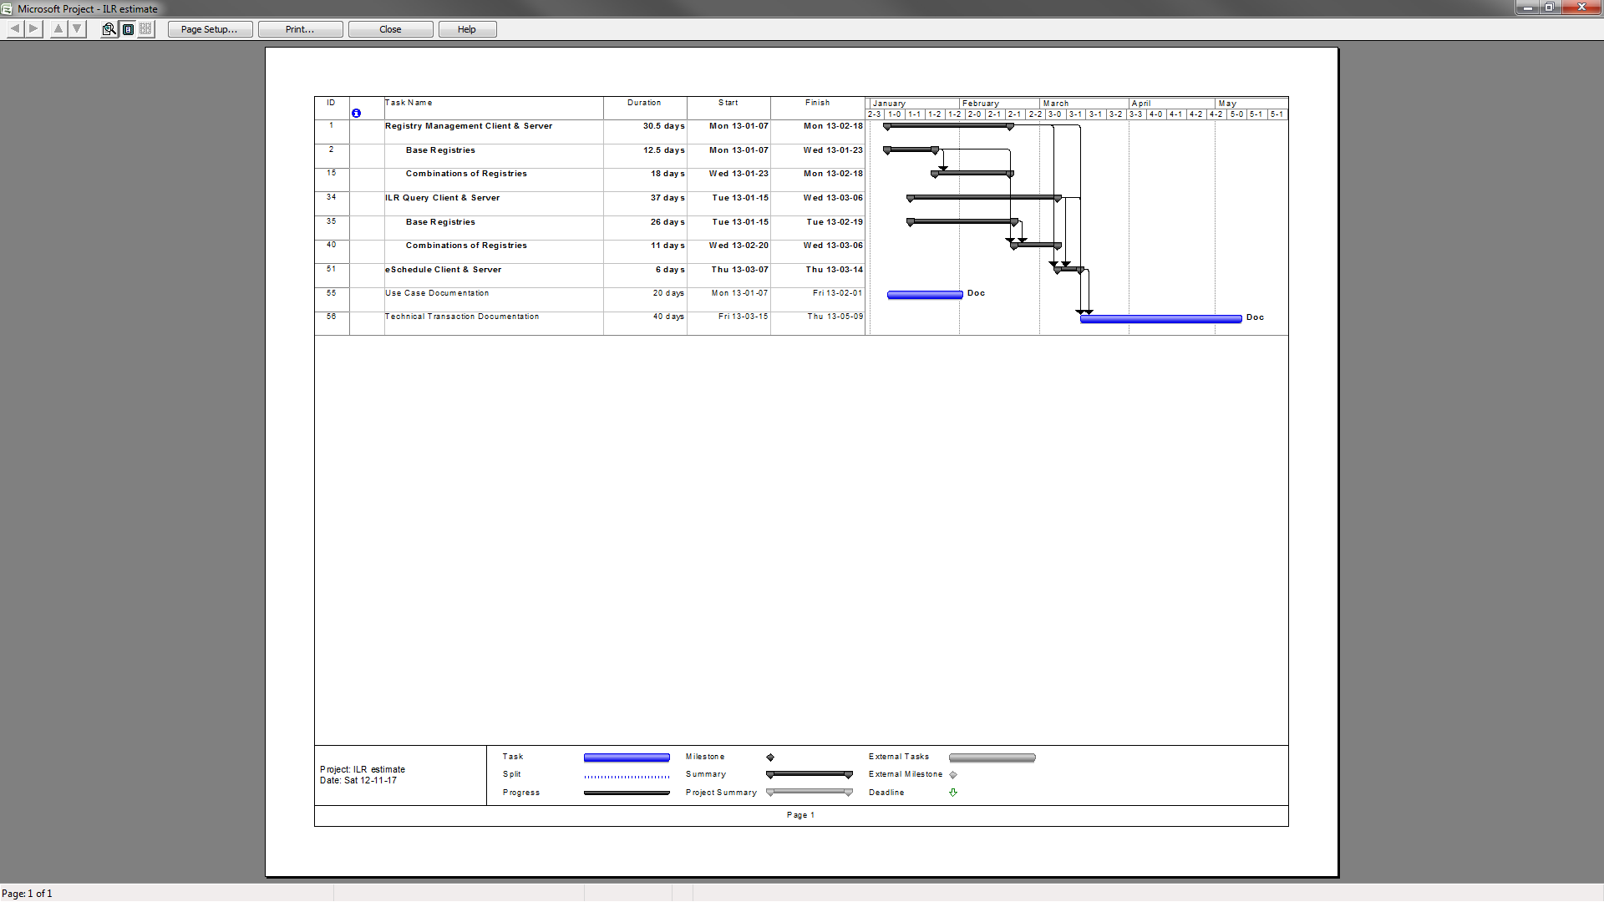

*Figure 5 – Project Estimate (Gantt Chart)*



*Figure 6 – Project Resource Workload Estimate*